Number format

Excel meetup: March 9th, 2021

# Value and Format

Obviously, it is not necessary to tell anyone, who works with Excel, that there is a difference between the value in the cell and the format under or behind a cell. The value can be seen in the Formula Bar. The formatted result can be seen on the worksheet. It does not matter to the value of the cell if the font, font size, font color, background color or the number format is changed – the value inside the cell is not changed by formatting. Sure? Do we have two independent levels?

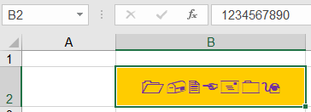

# Limitation of numbers

There are limits, when you inset a number: The limitation is 15:

* 15 digits before the decimal separator (in Germany: “,”)
* 15 digits after the decimal separator
* 15 digits in total

Ein Bild, das Tisch enthält.

But there are also limits concerning date (#1/1/1900# ≤ date ≤ 31/12/9999) and time (0:00 and 9999:59:59)

You find the list on:

<https://support.microsoft.com/en-us/office/excel-specifications-and-limits-1672b34d-7043-467e-8e27-269d656771c3>

or – on German:

<https://support.microsoft.com/de-de/office/spezifikationen-und-beschr%C3%A4nkungen-in-excel-1672b34d-7043-467e-8e27-269d656771c3>

# General and number

At first glance, numbers in cells formatted with the format “General” or “Number” seem to be the same (if you do not care about decimals). However, you can notice the difference when the number becomes large: 1212121212121212121 is converted to 1,21212E+14, when the cell is formatted as “General”. It is not converted into the scientific notation, if you use the format “Number”. It also works when entering a number with decimal places: A number formatted as number always has a fixed number of decimal places. If you insert a number with decimal places into a “general” cell , the number is formatted. It is rounded and not all the digits do appear in the worksheet. However, both number formats (General and Number) delete leading zeros.

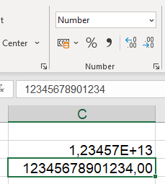

# Currency and Accounting

If this number represents a monetary amount, it can be formatted with “Accounting” or “Currency”. What are the differences?

Ein Bild, das Text enthält.

Excel in first sight uses the currency set in the Control Panel in Windows under “Locale”. But if you wish to change the currency, you can use the Format Cells-dialog box.

The list is divided into two halves: in the upper half the currencies are displayed as symbol or abbreviation, in the lower half there is the ISO standard 4217, which determines the currency with three letters.[1]

According to “general” and “number”, there are some differences between “Currency” and “accounting”:

* If you use “accounting”, there is a small gap between the text “EUR”, “GBP”, “USD”, “CHF”, … or the symbols“€”, “$”, “£” “¥”, “₽”, … and the grid line, in the case of “currency” there is no margin; the currency is always on the left or right side of the cell.
* Accounting represents 0 as - EUR (- €), currency as 0.00 EUR (0.00 €). Of course: “$”, “£” “¥”, “₽”, …
* If you uncheck the option “show a zero in cells with zero values”, - € is shown in “accounting”, an empty cell at “currency”.
* Negative numbers can be displayed in red font color only in currency format.
* A number formatted with “Accounting” cannot be centered.
* If the result of a cell is underlined in an accounting way, the cell of an accounting number is almost completely underlined, with the currency format only the digits are underlined.
* If a short text is formatted as accounting, there is a small gap between the left margin and the first letter.
* If “long text” (text with more than 253 letters) is formatted as an accounting, it is represented with ### (octothorp, hash tags or number sign) in the case of currency.

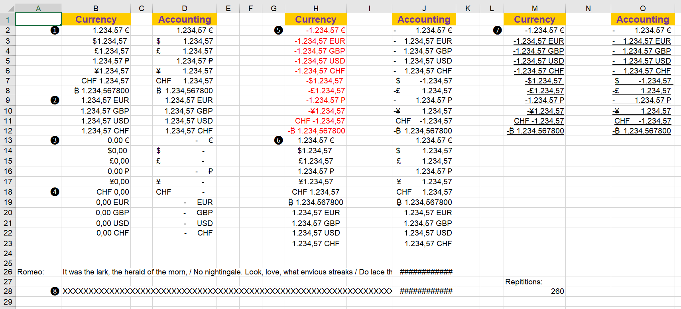

# Custom number format

Amazing! Do you know the function CONVERT? This function provides more than 100 units of measurement, which can be converted. Of course, you cannot convert meters to kilograms and of course there are many units in tens of potencies: mm, cm, m, km, ...

But it is very astonishing that none of these units of measurement can be found in the number formats in Excel. To be sure all the currencies of the world are found in the list. When in Turkey the Lira switched to the new Turkish lira (TRY) in 2005, this currency entered Excel in the next year. The current version also contains Bitcoin, unfortunately not Ethereum and not the Code BTC for bitcoin.

While the dollar sign is present on almost every computer keyboards and the euro sign can usually be created by pressing [Alt Gr]+[e], [Ctrl]+[Alt]+[e] or [Shift]+[Ctrl]+[Alt]+[e], other currency symbols are not found on the keyboard. If you need it, you can enter the ANSI code for the following symbols by pressing the [Alt] key on the right number keyboard:

| **Currency Symbol** | **Currency Name** | **Windows Shortcut** | **Mac Shortcut** |
| --- | --- | --- | --- |
| $ | Dollar Symbol | Shift + 4 | Shift + 4 |
| € | Euro Symbol | Alt + Ctrl + E | Option + Shift + 2 |
| $ | Dollar Symbol | Alt + 0036 | Option + 0024 |
| € | Euro Symbol | Alt + 0128 | Option + 20AC |
| ƒ | Dutch Florin | Alt + 0131 | Option + 0192 |
| ¢ | Cent Sign | Alt + 0162 | Option + 00A2 |
| £ | British Pound | Alt + 0163 | Option + 00A3 |
| ¤ | General Currency | Alt + 0164 | Option + 00A4 |
| ¥ | Japanese Yen | Alt + 0165 | Option + 00A5 |
| ㍐ | Square Yuan | Alt + 13136 | Option + 3350 |
| ֏ | Armenian Dram Sign | Alt + 1423 | Option + 058F |
| ؋ | Afghani Sign | Alt + 1547 | Option + 060B |
| ৲ | Bengali Rupee Mark | Alt + 2546 | Option + 09F2 |
| ৳ | Bengali Rupee Sign | Alt + 2547 | Option + 09F3 |
| ૱ | Gujarati Rupee Sign | Alt + 2801 | Option + 0AF1 |
| ௹ | Tamil Rupee Sign | Alt + 3065 | Option + 0BF9 |
| ฿ | Thai Baht | Alt + 3647 | Option + 0E3F |
| 원 | Korean Won | Alt + 50896 | Option + C6D0 |
| ៛ | Khmer Symbol Riel | Alt + 6107 | Option + 17DB |
| ﷼ | Saudi Arabiya Rial | Alt + 65020 | Option + FDFC |
| ﹩ | Small Dollar Symbol | Alt + 65129 | Option + FE69 |
| ＄ | Fullwidth Dollar Sign | Alt + 65284 | Option + FF04 |
| ￠ | Fullwidth Cent | Alt + 65504 | Option + FFE0 |
| ￡ | Fullwidth Pound Sign | Alt + 65505 | Option + FFE1 |
| ₠ | Old Euro Currency | Alt + 8352 | Option + 20A0 |
| ₡ | Colon Symbol | Alt + 8353 | Option + 20A1 |
| ₢ | Cruzeiro Symbol | Alt + 8354 | Option + 20A2 |
| ₣ | French Franc | Alt + 8355 | Option + 20A3 |
| ₤ | Lira Symbol | Alt + 8356 | Option + 20A4 |
| ₥ | Mill Sign | Alt + 8357 | Option + 20A5 |
| ₦ | Nigerian Naira | Alt + 8358 | Option + 20A6 |
| ₧ | Spanish Peseta | Alt + 8359 | Option + 20A7 |
| ₨ | Old Indian Rupee | Alt + 8360 | Option + 20A8 |
| ₩ | South Korean Won | Alt + 8361 | Option + 20A9 |
| ₪ | Israeli New Sheqel | Alt + 8362 | Option + 20AA |
| ₫ | Vietnamese Dong | Alt + 8363 | Option + 20AB |
| € | Euro Symbol | Alt + 8364 | Option + 20AC |
| ₭ | Laos Kip | Alt + 8365 | Option + 20AD |
| ₮ | Mongolian Tugrik | Alt + 8366 | Option + 20AE |
| ₯ | Greece Drachma | Alt + 8367 | Option + 20AF |
| ₰ | German Penny Sign | Alt + 8368 | Option + 20B0 |
| ₱ | Philippine Peso | Alt + 8369 | Option + 20B1 |
| ₲ | Paraguayan Guarani | Alt + 8370 | Option + 20B2 |
| ₳ | Argentine Austral | Alt + 8371 | Option + 20B3 |
| ₴ | Ukrainian Hryvnia | Alt + 8372 | Option + 20B4 |
| ₵ | Ghana Cedi | Alt + 8373 | Option + 20B5 |
| ₶ | Old Livre Tournois Sign | Alt + 8374 | Option + 20B6 |
| ₷ | Esperanto Spesmilo | Alt + 8375 | Option + 20B7 |
| ₸ | Tenge Sign | Alt + 8376 | Option + 20B8 |
| ₹ | Indian Rupee Symbol | Alt + 8377 | Option + 20B9 |
| ₺ | Turkish Lira | Alt + 8378 | Option + 20BA |
| ₻ | Nordic Mark | Alt + 8379 | Option + 20BB |
| ₼ | Azerbaijan Manat | Alt + 8380 | Option + 20BC |
| ₽ | Russian Ruble | Alt + 8381 | Option + 20BD |
| ₾ | Georgia Lari | Alt + 8382 | Option + 20BE |
| ₿ | Bitcoin Symbol | Alt + 8383 | Option + 20BF |

You can add any word before or after the numbers with a custom number format. Whether the space is inside the quotation marks or outside does not matter:

"Debt:" 0.00

corresponds to:

"Debt: "0.00

Alternatively, a “\” could be set in front of each character:

\D\e\b\t\: 0.00

Now you can format with the custom format:

* 1234 km
* 1235 m²
* 1236 m³
* 1237 °C
* 1238 hl
* 1239 kg

And so on.

If the number 1400000 should not to be represented as 1,400,000, but as 1.4 million, then it must be formatted:

# represents it as 1400000.

#. represents it as 1400.

#.. represents it as 1.

#..,# represents it as 1.4.

#..,# "MM" represents 1.4 million (MM).

It is changed automatically to:

#,00..

Ein Bild, das Text, rot, Anzeigetafel, Screenshot enthält.

Note

Unlike in Germany or Austria, in Switzerland the apostrophe is used as a thousand separators. There, the format above must be: #'',# or #'',# (two times “'”)

Note

The following characters can be used without using quotation marks: - + / ( ) : ! •& ‘ (single quotation mark on the left) ’ (single quotation mark on the right) .

If you are unsure about whether to use quotation marks or not: it is always a good idea to format these special characters as text, that means, to write them inside quotation marks.

| Digit/sign | meaning: | 1234,5678 | Formatted |
| --- | --- | --- | --- |
| 0 | A digit is mandatory. | 0 | 1235 |
| # | A digit is possible. | •#0 | 1,235 |
| ? | inserts spaces for non-significant zeros on both sides of the decimal place to align decimal numbers to the decimal point when formatting is done with a fixed-width font (for example, Courier New). You can use the character “?” also for fractions with a different number of digits. | ????,???? | 1234,5678 |
| , | Decimal separator | 0,00 | 1234,57 |
| . | Separator of thousand | #.##0,00 | 1.234,57 |
|  |  | #.##0.00 "kg" | 1,234.57 kg |
| ; | positive and negative numbers. .#0 "kg"; "#0 "kg"1,234.57 kg |  |  |
| ;; | positive, negative numbers and 0."#0 "kg"; [Red]---#0 "kg"; ""1,234.57 kg |  |  |
| ;;;; | positive, negative numbers, 0, and empty cells. . . #0 . . "#0 "kg";0;"" 1,234.57 kg |  |  |

Here is how to format:

"Profit:" 0,00;"Loss: "0,00

Perhaps you are wondering: who needs that? Answer: you can easily hide numbers by using ;;; — the value is still in the cell, but do not appear on the sheet. Even if the cell is formatted with a background color.

Other fields of application are diagrams for using “;;;”: for example, if you want to display negative numbers positively, it only works via the format 0;0 because there is no conditional formatting available in charts.

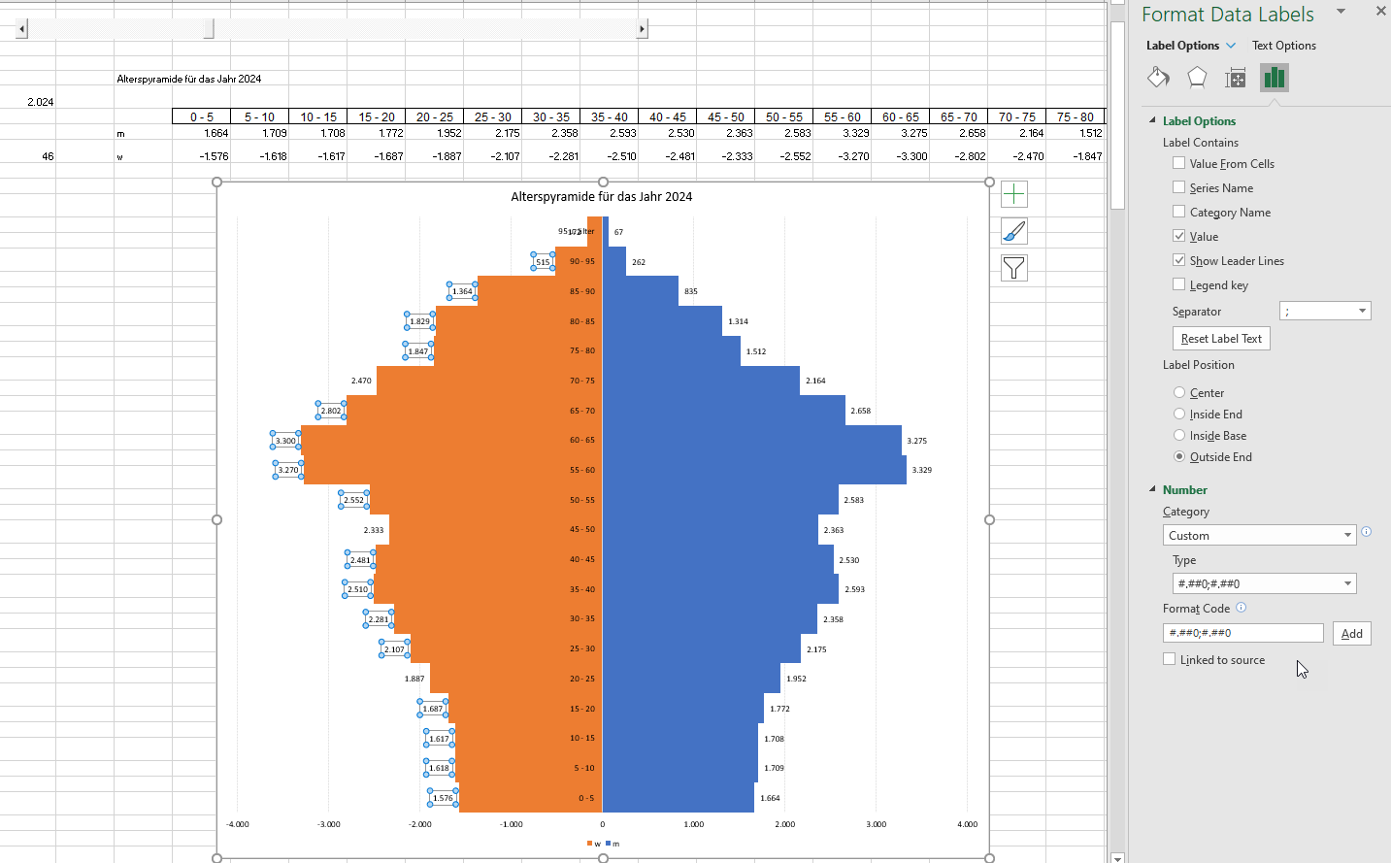

# ;;;

For the custom number format ;;; the four elements stand for:

* Positive number
* Negative number
* Zero
* Text

For example, it is possible to hide “rounding errors” in tables with a colored cell background, so numbers are represented as ..#0.0000;- ..#0.0000;. This allows you to hide rounding errors and is independent of a background color.

Note

Unfortunately the Add-In Inquire does not find the cells that are using ;;; formatted. White font color, on the other hand, is tracked down!

Ein Bild, das Tisch enthält.

This can be used, for example, in the following scenario:

In a form, a combo box (data validation) is intended to provide two variants: "No Selection;x". However, you do not want to appear the selected “no selection” text on the worksheet. So you can hide it, using conditional formatting (condition: text = "no selection"): Custom number format: ;;;

Thus, nothing is displayed in this selection.

Ein Bild, das Tisch enthält.

Another example in Pivottables:

Ein Bild, das Tisch enthält.
Ein Bild, das Tisch enthält.

In Excel (Word, PowerPoint & co) you can insert the two symbols “hook” and “cross”: ✓ and 🗶. You find them in the Font Wingdings – at the end of the list of the symbols. If you format them with a different font, you will find out which characters represent them.   
With that information you can create a selection list via a data check - with the two texts “done” and “in progress”.   
With the help of conditional formatting, you can now represent these two texts - ;;;"ü" or ;;;"û"" helps with this. The to-do list is ready and can be checked.

# Custom format and conditional formatting

With that information it is easy to format 1 to “1 year” , but 2 to “2 years”:

[=1]0,00 "year";[<>1]0,00 "years"

You can also use colors: The color for a section of the format is set by typing the name of one of the following eight colors in square brackets in the section. It is not case-sensitive, but converted to upper case after entering. The color code must be the first item in the section.

* Black
* Cyan
* Magenta
* Know
* Blue
* Green
* Red
* Yellow

This color could be used to define conditions:

[Blue][<100]0;[Green][>1000]0;General

Note

Unfortunately, you can only choose two color variants.

You can also create a color value using [Colorxx] - Excel provides 56 different values:

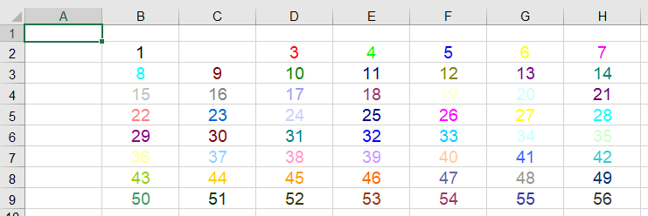

You can easily generate the values with a macro:

Sub WriteColor()

Dim xlZelle As Range

For Each xlZelle In ActiveSheet.UsedRange

xlZelle.NumberFormat = "[Color" & xlZelle.Value & "]"

Next

End Sub

In most of the cases it is certainly easier to use the conditional formatting. However, there are some places in Excel, such as charts, where conditional formatting cannot be used.

If you want to repeat the character that follows a number in the format to fill the column, include an asterisk (*) in the number format. For example, enter **0*-** to fill the cell with hyphens.

In this way you can use the custom formatting

[Blue][<0,8]0,00%;[Red][<0,95]0,00%;[Green]0,00%

[Color5][<0,8]0,00%;[Color26][<0,95]0,00%;[Color10]0,00%

You can easily create a dynamic font color in charts:

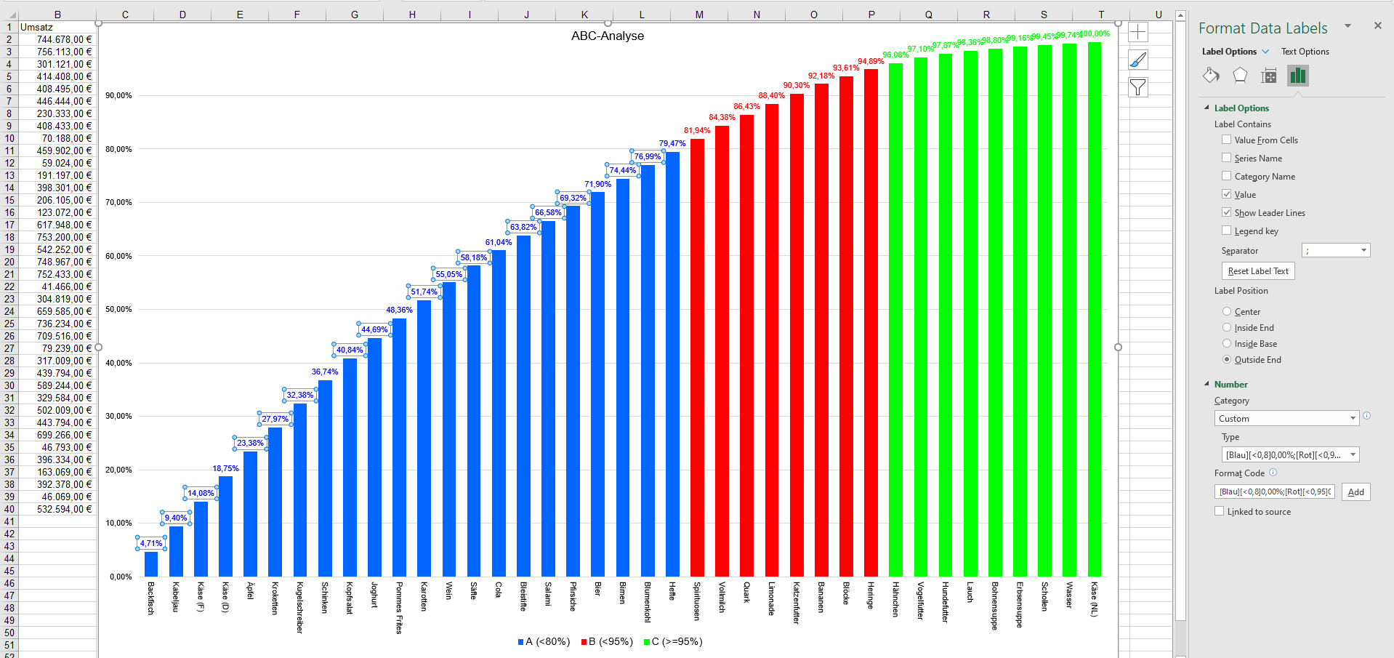

But also in VBA – because you only need one command for that number format, but several for the conditional formatting:

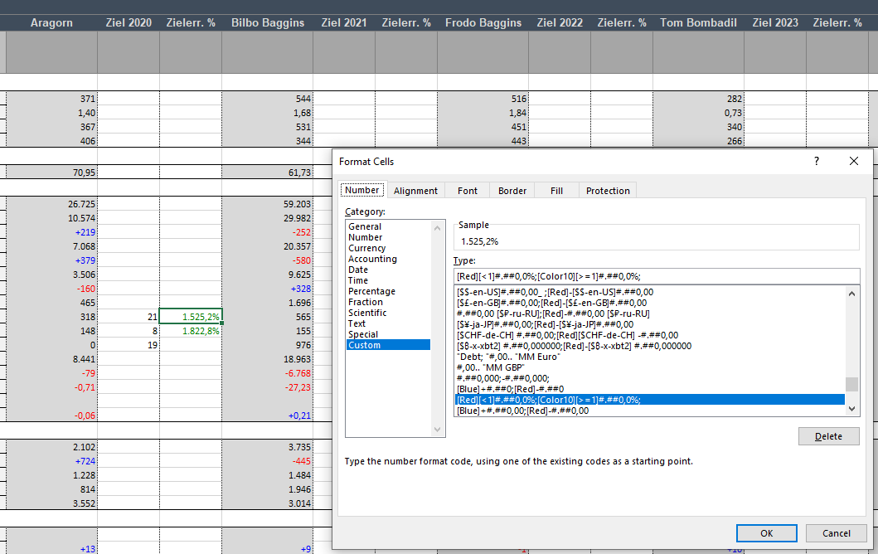

# More than three conditions?

This color could be used to define conditions:

[Blue][<100]0;[Green][>1000]0;Standard

Note

Unfortunately, you can use only two color variants.

If you need more than three colors or texts, you must resort to the “classic” (or: new) conditional formatting. For example, to display text in a chart.

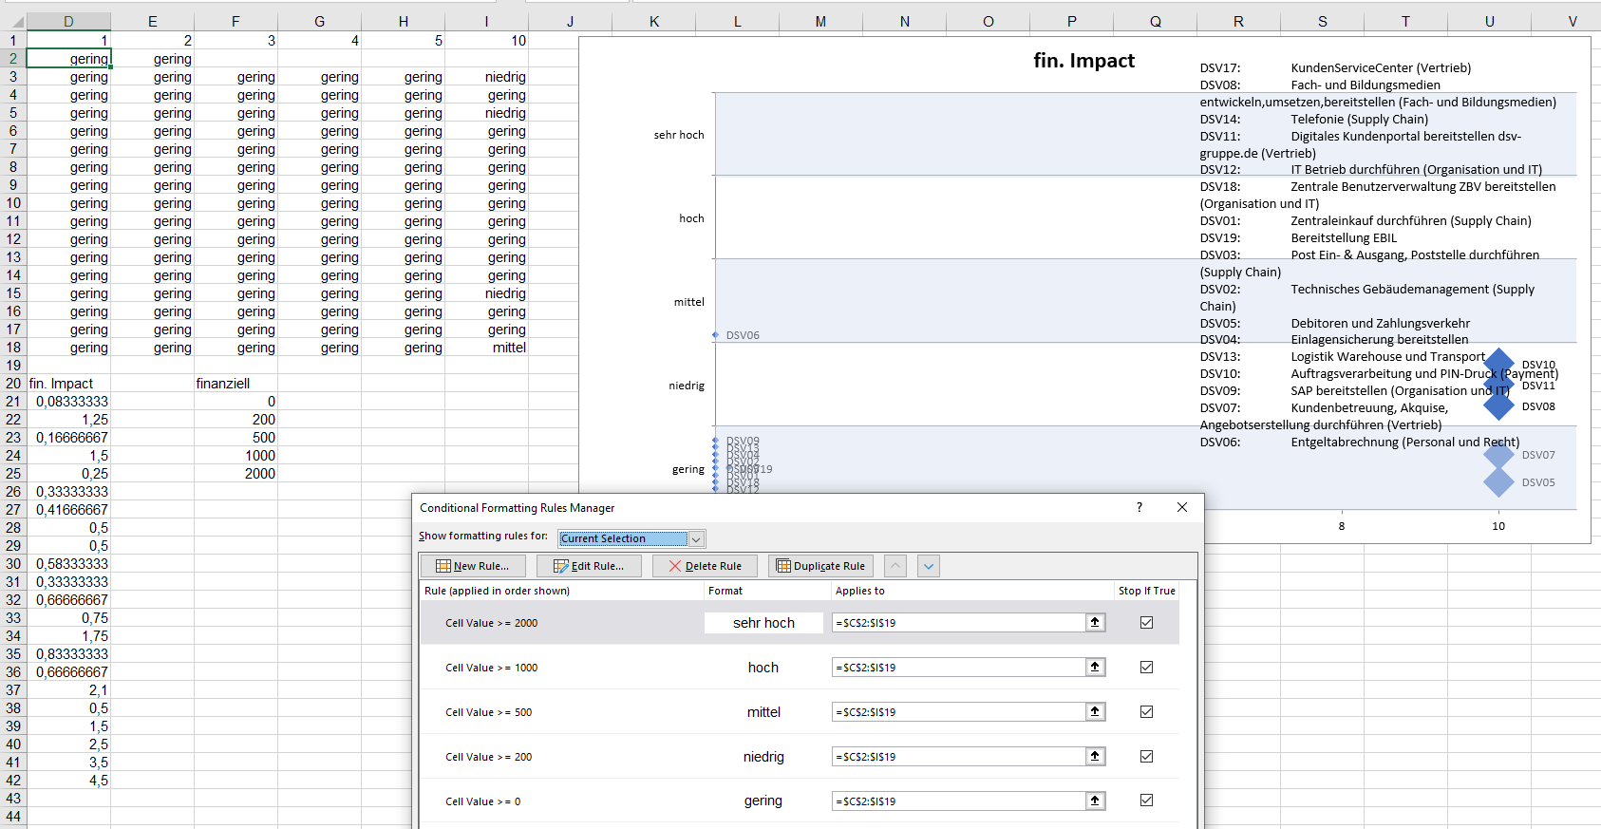

# Dates are numbers

The date and time in Excel is a little bit tricky. If you enter a date, such as 1.1.5, that date is immediately displayed as:

01.01.2005

Even a value such as May 1, March 2, or January 3 is “transformed” and displayed differently:

01. May, 02. Mar, 03. Jan

By the way, January 2020 will also be changed to Jan 20.

If you want a different representation, select it from the dialog box of the number formats from the Date category. Excel uses the date March 14th, 2012 as example. Here we use another date: 1.1.2021, a Friday.

| Character | Meaning | Presentation at 1.1.2021 |
| --- | --- | --- |
| D | Day, one digit | 1 |
| DD | Day, two digits | 01 |
| DDD | Day of the week in short form | Fr |
| DDDD | Day of the week in long form | Friday |
| M | Month, single digit | 1 |
| MM | Month, double digits | 01 |
| MMM | Month, as text in short form | Jan |
| MMMM | Month, as text in long form | January |
| YY | Year in short form | 21 |
| YYYY | Year in long form | 2021 |

Note

“D” and “Y” is not case sensitive, but “M”. All you enter in Excel can be entered in upper or lower case: all cell references, formulas, and functions. VBA is also not case sensitive to internal functions. Only “M” is reserved for the month, “m” for minutes! For example, a dd.mm.yy would result in the following erroneous representation:

01.00.21

Note

And be careful with the local representation of day, month and year. IN English you write D-M-Y, in German T-M-J, In Spanish D-M-A, in Turkish G-A-Y, …

If you want to represent the following date:

Friday, January 1, 2021

it must be formatted:

DDDD, MMMM D YYYY

Tip

Some Excel users like to type the numbers on the right number keyboard. To avoid having to use a typewriter keyboard to set a date point when entering dates, you can also use a minus (-) or a split character (/). You can also find them on the right side. Correct inputs are therefore:

1.1.20

1-1-20

1/1/20

Attention

The input 31-12-29 is interpreted as 31.12.2029, whereas 1-1-30 becomes 01.01.1930. In between runs the border. It is set in the operating system in Control Panel.

And how does Excel “knows”, that we are in Germany and “MMMM” means “Januar” and not, for example, January, Enero, Ocak or Leden? The answer can be found in the Windows Control Panel. Excel uses the country setting and displays the locale set in the number dialog. If “Austria” was set there, the first month of the year is formatted to “Jänner”.

What happens when a date is formatted into a number? A date, such as 09.03.2021, becomes the number 44264. The explanation is quite simple: each Excel date is internally stored as serial number. Excel starts counting on January 1st, 1900, which corresponds to the number 1. The 02.01.1900 is 2, the 3rd of January 3 and so on until 09.03.2021, which represents 44264.

By the way, Excel also has an upper limit: 31.12.9999 (or the number 2.958.465) That should be enough for now ...

There are consequences for assigning numbers to dates. This internal conversion method is the reason, why Excel “recognizes” quickly, that there is no 31.11.2021, and leaves the date left-aligned as text. A number will be found for 31.12.2021. Even when you pull down dates, Excel quickly detects how to “continue”.

However, if you write a date into a cell, delete the cell contents, and now enter a number, that number is formatted into a date. For example, if a cell has today's date, it is deleted and 500 (€) is entered, then the (currency) amount is converted to the date 14.05.1901.

Especially beginners are slightly confused by this. For example, if a beginner enters 2.5 instead of 2.5 on the keyboard, as he or she knows it from the pocket calculator, the number is converted to May 2. The effect of deleting is the clearing of the content, not the formatting. If 2.5 is typed correctly, it will be transformed into January 2. Only a correct deletion via Start | Delete | Delete all | Deleting formats or reformatting the Start cell | Number format helps.

By the way: In Excel, it is possible to format a custom date format according to a locale. Surprisingly, Excel does not provide as many different types in the Swiss and Austrian schemes as in the German scheme. And: A switch to the U.S. schema provides a type of MM-DDYYYY, while schemes such as Russian or Greek display the month names in the corresponding font. For example, 24 December 2020 will be converted to 24 Δεκεμβρίος 2020 or 24 декабря 2020 г. Even more astonishingly, Excel can convert to the appropriate calendar when formatting a date. The 24.12.2020 is correctly ۰۵ . ۱٤٤٢. ۰۹ (05/09/1442) or as a ٢٤. ١٢. ٢٠٢٠ (24.12.2020) if Arabic is chosen as language.

Ein Bild, das Tisch enthält.

Ein Bild, das Tisch enthält.

You can easily determine a country code. It consists of two letters for the language and two for the country: the language German corresponds to DE, Austria AT, Switzerland CH, French in France fr-FR, English from Great Britain en-GB, Russian from Russia ru-RU, Polish (Poland): pl-PL and so on. A drop-down field selects a language or country, searches for its code in a list, and uses the function to select today's date.

=TEXT(TODAY();"[$-"&C3&"] DDDD DD.MMMM YYYY")

The date will correctly be formatted.

Ein Bild, das Tisch enthält.

With that information it is easy to create a calender:

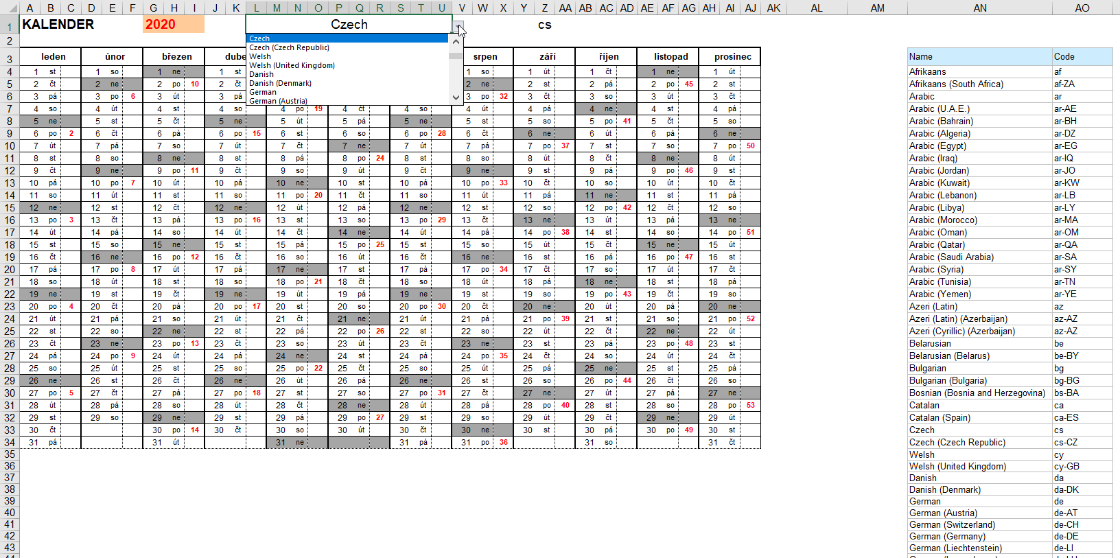

# Times are numbers

Tip

By the way: if you have to insert very often time information – you can replace two commas into a colon via autocorrect - and then 12,,30 is converted to the time 12:30.

A time of 12:00 (noon) can be displayed in several ways:

Ein Bild, das Text enthält.

|  |  |  |
| --- | --- | --- |
| Characters | Meaning | For example 08:05 |
| h | Hour in short form | 8 |
| hh | Hour in long form | 08 |
| [h] | Hours more than 24:00 (o’clock) | 08 |
| m | Minute in short form | 5 |
| mm | Minute in long form | 05 |
| s | Second in short form (not existing here) | 0 |
| ss | Second in long form (not existing here) | 00 |
| AM/PM | the US-American 12-hour time format | 08:05 AM |

If you want to sum hours (time information):

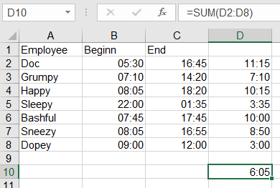

You must convert the format from hh:mm to [h]:mm:

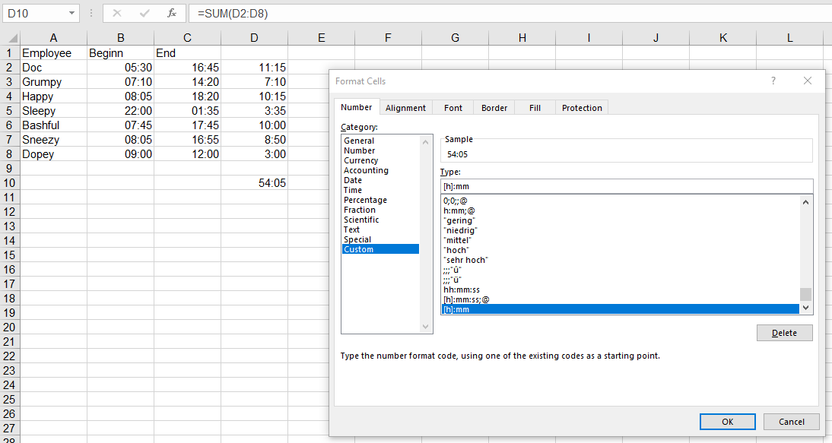

Here, too, various local forms are available – they use language-specific numeral characters

Note

If you format a time as "mm" in Excel, you save the file, open it again, convert Excel's to "MM"

# Text and number

Texts are formatted with “@”. This can be found out, if you format a number with the format “Text” and then change to the category “Custom”.

With [Alt] + number < 32 a non-printable character can be created. This symbol can be used in the custom number format, for example:

• @

This, however, could be saved as a cell style – why not with indentation?

Ein Bild, das Tisch enthält.

# SAP & co

Do you know SAP? He is my friend!

No, it was very ironic. Everybody who frequently exports data from SAP or other database systems does certainly know this problem: From time to time, text information is stored under the cells. Surprisingly, that is invisible – the cells are formatted as “general”. Sometimes you can find out, that there is text information behind the cell, because these numbers are left-aligned. At the latest you find it out, if you want to continue calculating with the numbers or if you want to sort or filter the numbers or format them as numbers ... then you notice that Excel throws a spanner in your bill.

Ein Bild, das Tisch enthält.

Looks like numbers, but it is text.

I have found the following solutions to this problem:

1. If you have luck and see the small green triangle (the indicator for error checking), you can convert the “texts” back to numbers.

Ein Bild, das Tisch enthält.

2. If you have only a few cells, you can double-click the cell (or edit the cell with [F2] and then exit with [Enter]. Then Excel uses the correct number format.

3. You can multiply the value of the cell by 1 with the help of an auxiliary column (=O2*1). Drag down the formula, copy it, and paste the content as values.

4. The same is done by the function =VALUE

5. Or: use the calculation operator - -

6. Write the number 1 to an empty cell. Copy the cell, select the range of the text numbers and paste /multiply with content (context menu) “over”. The result is the same as in point 2 or 3 or 5 – Excel now uses the correct number format.

Ein Bild, das Tisch enthält.

7. My favorite tip: You can select the columns and use the wizard “Text To Columns”, which is found in the “Data” tab. Enter an absurd delimiter there (for example, a tab – a separator, which of course does not exist in the numbers. Then the wizard overwrites the values with himself and “takes” the correct format and value, that is, the number format.

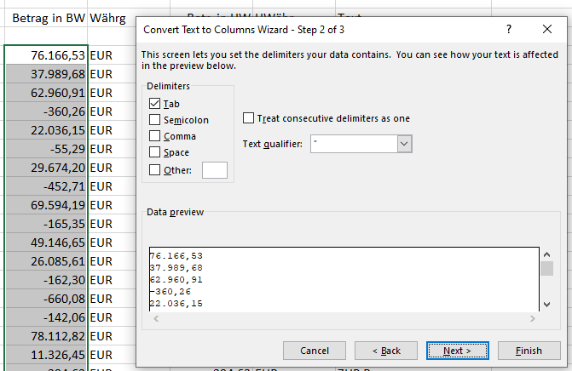

To save SAP’s honor, it should be noted that many database systems, for example: DATEV, KISS, ORBIS, EBIS and others, sometimes (not always!) push text formats under numbers when exporting to Excel.

By the way, this behavior is easy to simulate with a macro like:

Sub ConvertNumberToText()

Dim s As String

s = InputBox("Please enter a number!")

ActiveCell.Value = s

End Sub

This converts the number 17,5 to the text "17,5".

Ein Bild, das Tisch enthält.

# Percent

Again and again, I am astonished in Excel-trainings when participants write 0,19 and then format the value as percentage. When I am surprised and tell them, that you can also write 19%, some persons are amazed. Or 16% or 20% ...

The percentage format is intended to add a quotient not as a decimal number, but as a percentage.

Ein Bild, das Tisch enthält.

Note

There is an option “enable automatic percentage entry”, which causes the percent sign as suggestion of the number formatting with the percent format.

Attention

Unfortunately, there is a difference between the icon “%” and “percentage” of the combo box: The first one does not have any decimal places, the second one uses two.

# Scientific

If you enter “very large” or “very small” numbers in Excel, for example, the length of a light year in meters: 9.460.730.472.580.800, Excel converts this number to 9,46073E+15, if you used the general format. If you specify the speed of light in m/s: 299.792.458, you could also enter 2.99E+08. Excel converts to the “Science” number format starting from the twelfth digit.

Problems occur when text number combinations are imported with an "E", for example, gene names:

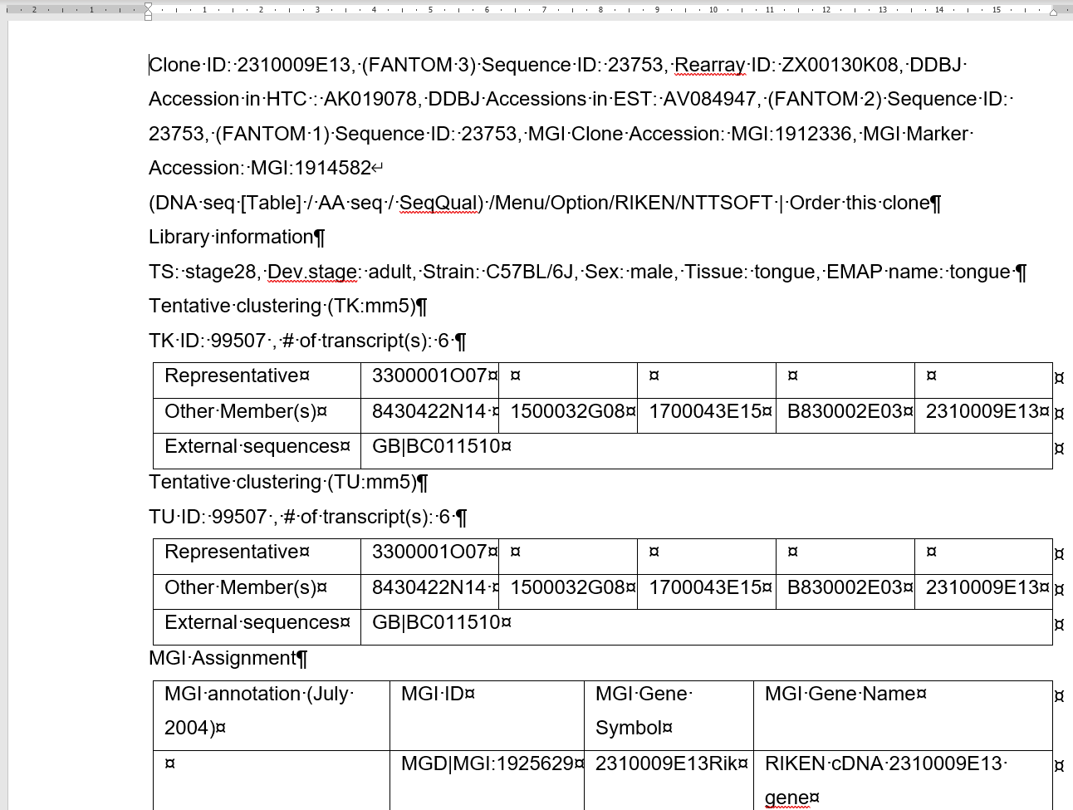

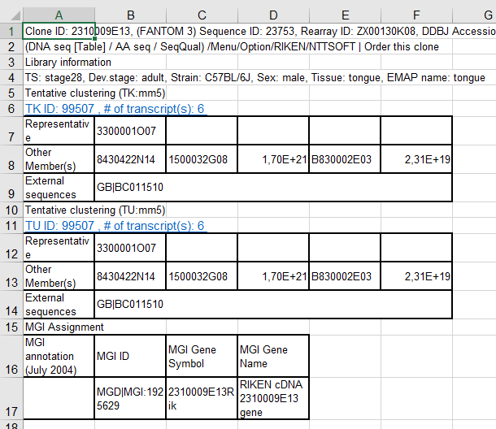

Genetic research has therefore considered renaming some gene names:

<https://www.theverge.com/2020/8/6/21355674/human-genes-rename-microsoft-excel-misreading-dates>

or in German:

<https://www.spiegel.de/netzwelt/web/fuer-microsoft-excel-forscher-benennen-menschliche-gene-um-a-0d80a025-85af-4652-ace1-e29bb96109f1>

# Logical (boolean) Value(TRUE, FALSE)

Unlike openOffice or libreOffice Calc, Excel does not have its own format for logical values. Although truth values in Excel represent a separate data type (besides text and number), which can be verified with ISLOGICAL, Excel does not provide a number format for it.

In Excel = ISNUMBER(TRUE) returns FALSE, in Calc it is TRUE.

However, this can cause, that Calc unintentionally displays numbers as TRUE in a table.

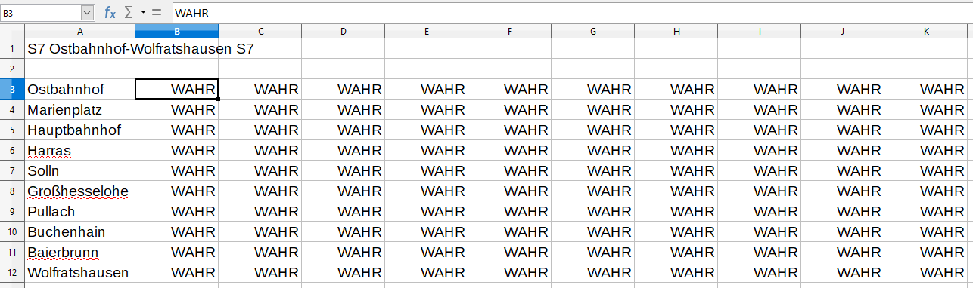

# Talking German– differences between Germany and Austria and Switzerland

There are some small differences in number formats. The date of the first month of the year is displayed in Austria with the format MMMM as “Jänner”, in Germany and Switzerland as “Januar”.

The thousands separator used in Switzerland is: “'”, in Germany and Austria is “.”. This means: the number format

#..,# "Mio."

Does not work in Switzerland - it has to changed there into

#'',# "Mio."

# Excel formats “automatically”

Attention is required for “mixed” number formats. If three numbers, which are among each other, are formatted in the same way, for example as a currency, then each number entered below this range is automatically transferred to the same format. This can be useful for currency or certain number formats, but can also be irritating or: wrong! It depends.

Note

This option can be deactivated in the options Advanced | Editing options via “Extend data range formats and formulas”.

1. Very amusing: you can also find “bitcoin” on the list.