Excel Business Bootcamp Exam 2
You have received an Excel workbook containing four worksheets (Sales List, Reps, Stores and Products). These sheets contain data that we need to generate two reports.
There is also a worksheet named By Date. This will be used for one of the reports.
You will go through a series of tasks to combine the data into one list and then create the two reports.
- Convert the Sales List range into a table and name the table Sales. (2 pts)
- Include the Product Name, Product Category, Store Name and Sales Rep fields in the Sales List table. (8 pts)
You will need to look up and return this data from the necessary tables using the ID fields provided.
- Product > Product Name and Product Category
- Store > Store Name
- SP ID > Sales rep.
An example of the finished sales table is shown below.
The columns do not need to be in the same position as the image. But please ensure they are all included. We will need them.
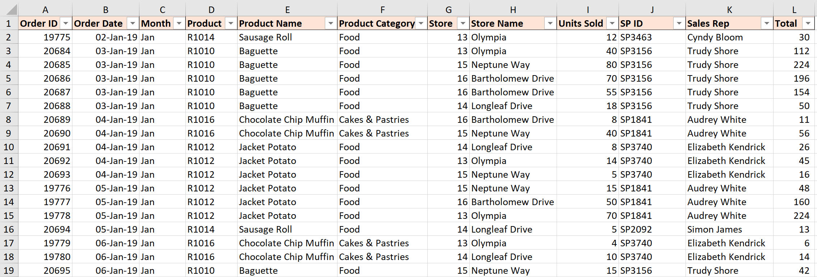

- Create a PivotTable on a new worksheet named Report. This PivotTable will show the Total sales for each Product Name. It will also include the Product Category as a filter. (5 pts)
- Create another PivotTable on the same worksheet (Report) and use it to show the Total sales and count of sales for each Store Name. (5 pts)
Below is an image of the two completed PivotTables.
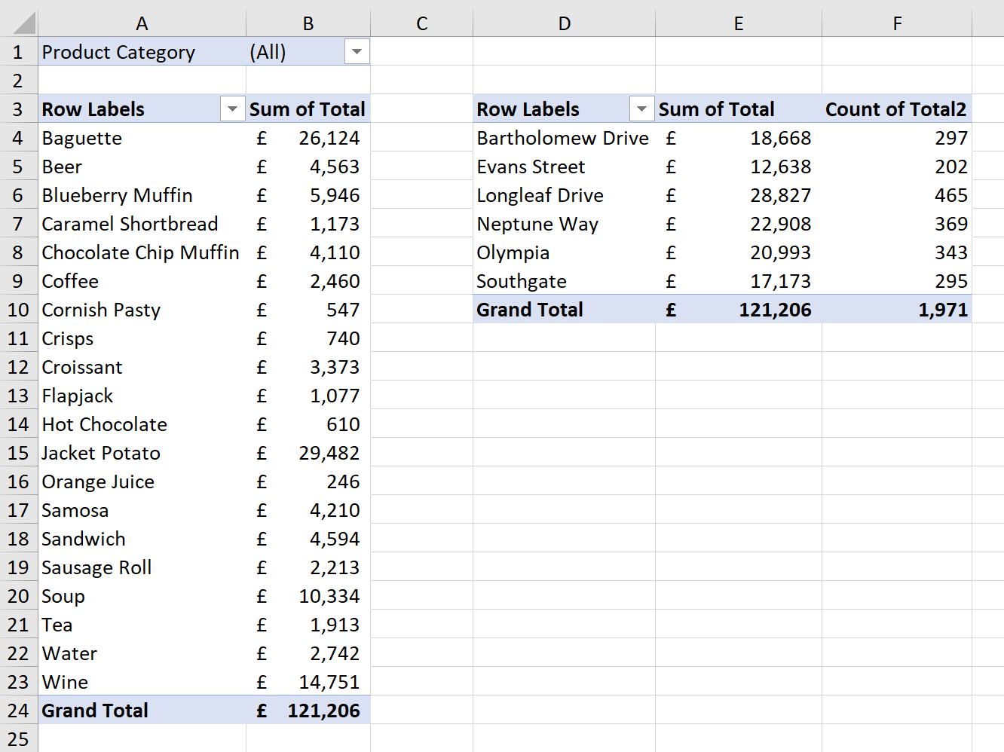

Go to the By Date worksheet. Perform the following tasks so that the report looks like the image at the bottom of the page.
- In cell A5, write a formula to sum the sales totals for all sales since the date in cell B2. (5 pts)
- In cell B5, write a formula to count the number of sales since the date in cell B2. (5 pts)
- In cell B8, write a formula to sum the total sales since the date in cell B2 and the store name in cell A8. Copy this formula down for each store name. (7 pts)
- Create a column chart from the data in range A7:B13 and position it to the right of the formula results. Make the following changes to the chart so that it looks the same as in the image at the bottom of the page. (5 pts)
- Change the chart title to Sales by Product.
- Remove the Primary Horizontal Gridlines.
- Remove the Primary Vertical Axis.
- Create a PivotTable and position it on the existing By Date worksheet in cell A18. Show the sales for each Sales Rep and for each Month of the year. Use the Store Name for a filter (in the image the filter is set to Southgate). (5 pts)
- Add a Conditional Formatting rule to range B20:M28 to change any value greater than 400 to green. (3 pts)
