

Table of Contents

About Me 4

Shortcuts 6

1. Double Click for a Quick AutoFill 6

2. Duplicate Cell Content 6

3. Navigate with the Name Box 6

4. Switch Between Worksheets 7

5. Quickly Enter Today’s Date 7

6. Select the Current Region 7

7. Format Cells, Please 7

8. Copy Formatting to other Cells 8

Formatting 9

9. Wrap Text 9

10. Clear Cells 9

11. Show the Day of the Week 10

12. Check if a Date Occurs This Month 11

13. Tracking Due Dates That Have Passed 12

Formulas 13

14. TODAY() and NOW() 14

15. Use COUNTA() to Count All Non-Blank Cells 14

16. Perform a Lookup with the Infamous VLOOKUP Function 15

17. Remove Spaces from a Cell 16

18. Calculate Loan Payments 17

19. The Magical IF Function 18

20. Find the 2nd Largest Number in a Range 19

21. Show Formulas 19

Excel Tools 20

22. Freeze Parts of a Spreadsheet 20

23. Hide Columns 21

24. Use Custom Lists 22

25. Use Named Ranges 23

26. Convert a Cell Range from Rows to Columns 24

27. Split a Full Name into First Name and Last Name Columns 25

28. The Camera Tool 26

29. Create a Drop Down List of Options 27

30. Convert a Cell Range to a Table 29

31. Use Sparklines for In Cell Micro-Charts 30

Printing 31

32. Print your Headers on Every Page 31

33. Print your Selection 32

34. Print to One Page 33

35. Remove the Gridlines from a Sheet 34

Using Charts 35

36. Build a Chart 35

37. Change the Scale of a Chart Axis 36

38. Apply Data Labels to a Chart 37

39. Add a Secondary Axis 38

40. Save the Chart as a Template 39

# About Me

Hello everyone,

My name is Alan Murray. I live in Ipswich in the United Kingdom with my wife and 2 children.

I work as an IT Trainer and have done for the last 20 years.

Working as an IT Trainer, I visit many organisations to train their staff in the use of Excel.

This means I get to meet many wonderful people and also get a good understanding of what Excel skills users’ need, and want to know.

I set up Computergaga to help spread these in-demand tips and skills to others.

I’m an Excel enthusiast and am always learning myself, because of this I would love to hear from you and encourage comments and a community spirit on my blog. I hope to see you there.

You can also follow me on [Twitter](http://www.twitter.com/Computergaga1) and [Facebook](http://www.facebook.com/Computergaga).

Learn More Than 100 Excel Formulas

Enrol in the **Excel Formulas Made Easy** course for Just **$10**



Get **Instant Access** to Lessons Including…

* **IF Functions**
* **Solving Formula Errors**
* **VLOOKUP**
* **Working with Percentages**
* **Date and Time Calculations**
* **Advanced Formulas**
* **The New 2016 Functions**
* **And much, much more**

Files can be downloaded for practise, and quizzes to test your knowledge.

Your instructor on hand to answer any questions you may have.

[Click Here to Enrol for Just $10](https://www.udemy.com/excel-formulas-made-easy/?couponCode=ExcelFormulasComputergaga)

# Shortcuts

## Double Click for a Quick AutoFill

The AutoFill technique is used to copy formulas, date sequences and Custom Lists amongst many others. It’s a brilliant tool that greatly improves data entry and the copying of formulas.

The AutoFill technique can be performed even quicker by double clicking on the AutoFill handle. This will only work for as long as the column to its left has content.



## Duplicate Cell Content

Something Excel demands is a lot of data entry. All those rows of data have to come from somewhere and unless there is a connection to a data source then it is being entered.

The **Ctrl + D** shortcut stands for duplicate and repeat the content of the cell above. I heavily rely on this shortcut as often the next row uses the same date, name or category as the previous row. This saves time and improves accuracy.

The great thing about Ctrl + D is that it copies the cell’s formatting as well as its content. There is also the **Ctrl + ‘** shortcut which only copies the content.

## Navigate with the Name Box

The Name Box to the left of the Formula Bar can be used to navigate an Excel spreadsheet. It is great for leapfrogging large amounts of data. So even if you do not know the exact cell reference that you need, you can jump to the rough area of where you need to be.

Click inside the Name Box, type the cell reference you want to go to and press Enter.

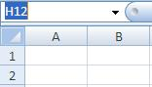

## Switch Between Worksheets

To quickly switch between the sheets of a workbook use the **Ctrl + Page Up** and **Ctrl + Page Down** keyboard shortcuts. Using these shortcuts saves having to click on the little tabs at the bottom of the book each time.

## Quickly Enter Today’s Date

Never have to check the calendar or type those pesky forward slashes again when entering today’s date, as the **Ctrl + ;** shortcut is there to do it for you.

## Select the Current Region

One of the most beautiful keyboard shortcuts in Excel must be **Ctrl + Shift + 8**. This shortcut will select your current region. This means it selects all the cells in the range that you are currently within.

Selecting hundreds and thousands of cells just became easy.

## Format Cells, Please

Format Cells is the most important dialog box in Excel. There you go, I said it. It’s more important than Print, Page Setup or Data Validation. And because of this, the keyboard shortcut should be known and used.

Its **Ctrl + 1**.

## Copy Formatting to other Cells

A common task in Excel is to copy formatting from one cell to another. It could be that you want to copy the specific shade of colour you used to fill another cell, a custom format or some conditional formatting rules.

The Format Painter is a fantastic tool that will enable you to do all of the above.

1. Select the cell that contains the formatting you want to use.
2. Click the **Format Painter** button on the **Home** tab.

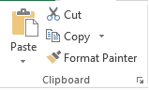

1. Select the cell(s) you want to apply the formatting to.

Double click the Format Painter button to keep it on so that you can paint the formatting to multiple ranges. Just remember to click the Format Painter button again when you are finished to turn it off.

# Formatting

## Wrap Text

If you are using a column in your Excel spreadsheet to store a description or comments, you need to know how to wrap text. Wrap text will display content on multiple lines within a cell to make it visible no matter how much you type.

1. Select the cells that you want to apply wrap text to.
2. Click the **Home** tab on the Ribbon.
3. Click the **Wrap Text** button in the Alignment group.

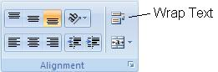

## Clear Cells

Pressing the Delete key in Excel only removes the contents of a cell. It will not remove formatting, Data Validation, comments or hyperlinks.

If a cell is not properly cleared it can cause problems in the future by formatting cells incorrectly, or preventing data from being entered due to validation rules.

1. Click the **Clear** cells button in the Editing group of the **Home** tab.

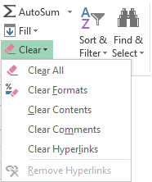

1. Select the option you want from the list.

## Show the Day of the Week

The date can be formatted to show the day of the week in a cell. This is not one of the provided date formats by Excel, but can be created as a custom format.

1. Select the cell(s) you want to format.
2. Click the **Home** tab on the Ribbon.
3. Click the **Number Format** list arrow in the Number group and select **More Number Formats**.
4. Select **Custom** from the **Category:** list.
5. Enter **dddd** in the **Type:** box.

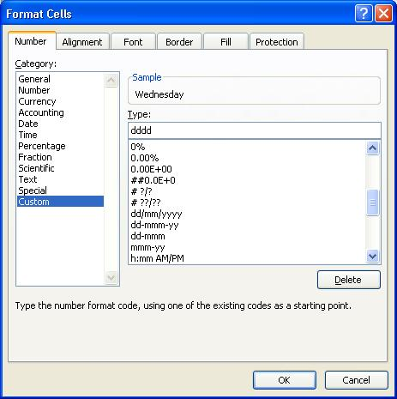

1. Click **Ok**.

## Check if a Date Occurs This Month

The Conditional Formatting tool can be used to bring your attention to almost anything you care to monitor in an Excel spreadsheet.

To be notified if a date occurs this month;

1. Select the range of cells containing the dates that you want to check.
2. Click the **Home** tab of the Ribbon.
3. Click the **Conditional Formatting** button in the Styles group.
4. Select **Highlight Cell Rules** and then select **A Date Occurring**.

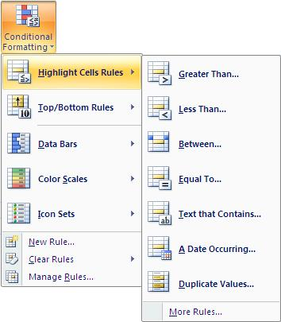

1. Click on the drop list arrow and select **This Month**.

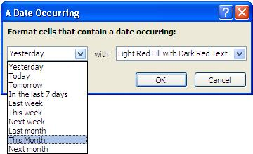

1. Choose a format from the second drop list arrow.
2. Click **Ok**.

## Tracking Due Dates That Have Passed

You may need to be made aware of dates that have passed on a spreadsheet such as an expiry date of a contract, or the due date of a payment.

By using the TODAY function within a Conditional Formatting rule it is possible to format the cells containing dates that have passed. This makes it easy to identify them on a spreadsheet.

1. Select the cells that contain the dates you want to format.
2. Click the **Conditional Formatting** button on the **Home** tab.
3. Select **New Rule** from the menu.
4. Select the **Format only cells that contain** rule type from the list.
5. In the rule description area change **between** to **less than**.
6. In the box to the right, enter =TODAY().
7. Click the **Format** button and select the formatting you wish to apply to dates in the past.

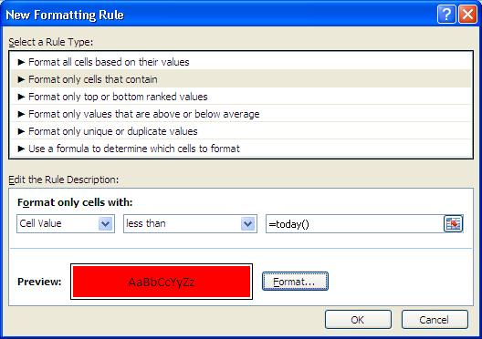

1. Click **Ok**.

**FREE Excel Formulas for Beginners Class**

[Enrol Now](http://skl.sh/2bCJHFK)



Get up to Speed with Excel Formulas and learn…

* 8 Useful Functions you can use Immediately
* Calculating Percentages such as Discounts, Bonuses and the Percentage Difference between Values
* How to Reference Different Worksheets and Workbooks
* Calculating the Number of Days Between Two Dates
* Calculating the Number of Working Days Between Two Dates
* Relative and Absolute Cell Referencing
* The Wonderfully Useful and Versatile COUNTIF Function

[Click Here to Enrol Now](http://skl.sh/2bCJHFK)

# Formulas

## TODAY() and NOW()

The TODAY and NOW functions are used to calculate the current date. This is extremely useful as by finding the current date you can calculate how long it has been since a specific date, or how long until an important due date.

The TODAY function returns today’s date, and the NOW function returns today’s date and the current time.

These functions require no arguments and can be entered into a cell as below.

=TODAY()

=NOW()

An example of its use to calculate the number of days until a due date (cell A2) is shown below.

=A2-TODAY()

## Use COUNTA() to Count All Non-Blank Cells

Microsoft Excel contains many statistical functions, which include a few variations of count functions. The COUNT function will only count the cells that contain numbers in them. Fortunately the other variations cater for anything else you may wish to count.

An important one to know is COUNTA. This function counts all the cells that are not blank. This means it counts cells containing numbers, text, formulas and even error messages as long as it has something in it.

It is written in the same way that the COUNT is. For example the function below counts all the non-blank cells in the range A2:A50.

=COUNTA(A2:A50)

## Perform a Lookup with the Infamous VLOOKUP Function

The VLOOKUP function is the most used lookup and reference function in Excel. You have probably heard of it.

It looks for a value in the first column of the lookup table and returns an associated value from a different column of the table. The V in its name stands for Vertical. For example, it can look for a product code and return the products minimum storage temperature.

VLOOKUP requires 4 items of information (arguments) in order to work.

=VLOOKUP(lookup_value, table_array, col_index_num, [range_lookup])

* **Lookup value** – The value you are searching for.
* **Table array** – The range of cells that you want to search for the lookup value within. VLOOKUP always looks down the first column of this selected range.
* **Col index num** – The column number of the table array that stores the information you want to return about the value.
* **Range lookup** – The type of lookup to be performed. Enter TRUE for an approximate match, or FALSE for an exact match. The default option is TRUE. When using the approximate match the lookup table must be sorted by the first column.

Most VLOOKUP examples involved performing an exact match. In this example, the VLOOKUP function has been used to return the unit price of a product from the table.

=VLOOKUP($H$4,$A$2:$F$78,4,FALSE)

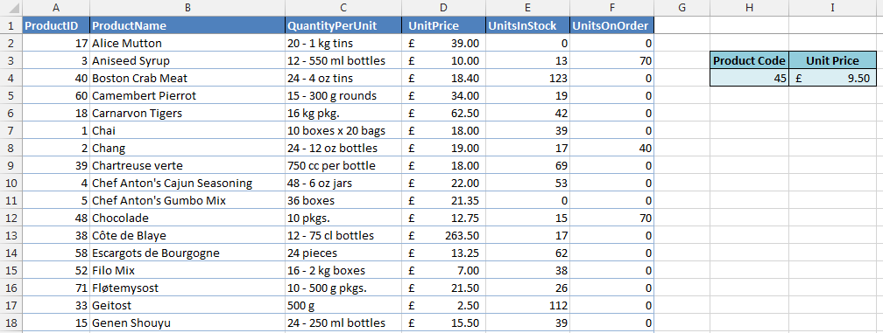

When performing an exact match it is not necessary for the first column of the lookup table to be sorted in ascending order.

See more advanced examples in this [Ultimate VLOOKUP guide](http://www.computergaga.com/tips/ultimate_vlookup_guide.html).

## Remove Spaces from a Cell

If a cell contains excess spaces at the beginning or end of the content it can produce wrong results in your formulas, PivotTables and charts. Spaces are considered a text character and mean that John without a space and John with a space on the end, although they look the same, are in fact very different.

To remove unnecessary spaces from a cell you should use the TRIM() function. This will not only remove unnecessary leading and trailing spaces, but also any extra spaces between words.

For example, =TRIM(A6) would remove all the extra spaces in cell A6.

## Calculate Loan Payments

The PMT function in Excel is used to calculate the payments on a loan. The anatomy of the function is;

=PMT(rate, nper, pv, [fv], [type])

* **Rate** – The interest rate per period on the loan. For example, 5%/12 for monthly payments on 5% APR.
* **Nper** –.Number of periods or payments on the loan.
* **Pv** – The present value. The total amount the payments are worth now.
* **Fv** – The future value. The balance after the last payment is made. If left empty the fv is set to 0.
* **Type** – When are the payments made? Enter 1 if payments are made at the beginning of the period, and 0 if payments are made at the end of the period. If left empty then 0 is used.

The example below show the PMT function being used to calculate loan payments form the data in the image.

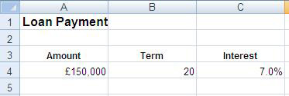

=PMT(C4/12,B4*12,A4,0,1)

£1,156.20 in monthly payments

* C4/12 - annual interest rate divided by 12 to return the monthly rate.
* B4*12 - period of loan in years multiplied by 12 to return the number of monthly payments
* A4 - loan amount that I owe.
* 0 - The final total after the last payment will be 0 as the loan is completely paid off.
* 1 - Payments will be made at the beginning of each period.

## The Magical IF Function

The IF function, is a logical function that tests a condition, and takes a different course of action depending on the result of the test. For example, it may test if a salesperson has met their sales target and calculate a bonus if they have, but display 0 if they have not.

The IF function is a key function behind many powerful automated spreadsheets. It brings that decision making intelligence to a spreadsheet.

The IF function requires three items of information;

=IF(logical_test, [value_if_true], [value_if_false])

**Logical test** is the condition that you want to test.

**Value if true** is the action you want to take if the condition is met.

**Value if false** is the action you want to take if the condition is not met.

For example, the IF function below is used to test if the value in cell B2 is greater than 1000. If it is then it will calculate 2% of the value in cell B2, and if not it will display 0.

=IF(B2>1000, B2*0.02, 0)

In the image below, this formula has been entered into cell C2.

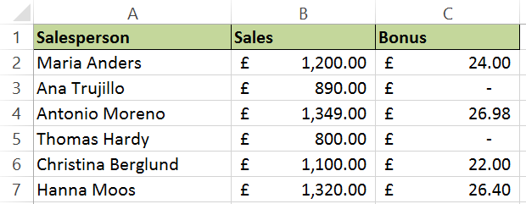

## Find the 2nd Largest Number in a Range

To find the largest number in a range you use the MAX function. But what if you need the 2nd 3rd or 5th largest number in a range? You need the LARGE function.

The Large function will return the k-th largest number in a range. It requires two bits of information from you in order to work.

=LARGE(array, k)

**Array** – This the range of cells you want to evaluate.

**K** – This is the ranking in descending order for the number you want returned. For example, 2 would return the 2nd largest number.

## Show Formulas

The ability to show formulas in a cell instead of the result is a fantastic tool for diagnosing formula errors.

Excel provides a few features to aid you in diagnosing why a formula is not working. These include Trace Precedents, Error Checking and the Watch Window. However Show Formulas enables us to easily read the formula syntax when diagnosing wrong outcomes and logical errors.

1. Click the **Formulas** tab on the Ribbon.
2. Click the **Show Formulas** button in the Formula Auditing group.

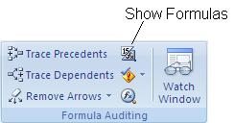

The values are hidden and the formula is displayed instead. This can help in identifying where something may be going wrong.

Click the **Show Formulas** button again to turn it off. The **Ctrl +`** keyboard shortcut can also be used to show and hide formulas.

# Excel Tools

## Freeze Parts of a Spreadsheet

Excel provides a fantastic feature called Freeze Panes to fix parts of a spreadsheet in place so that they are always visible as you scroll down or across a worksheet. 99% of Excel worksheets will be larger than the number that can fit on a monitor screen, making this feature a “must know”.

1. Select the cell on the worksheet that is directly after the row and column that you want to freeze e.g. if you want to freeze the headers in rows 1-3 then select A4, if you want header rows 1-3 and column A then click B4.
2. Click the **View** tab on the Ribbon and click the **Freeze Panes** button in the Window group.

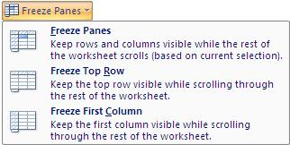

1. Select **Freeze Panes**.

If are just looking to freeze the top row or first column, then the pre-set options in the list will work a treat.

## Hide Columns

Hiding columns in Excel is especially useful for printing on fewer pages, or to hide cells containing intermediary formulas.

To hide columns;

1. Select the column(s) you want to hide.
2. Right click on the column and select **Hide**.

The columns are hidden. The sheet is not protected so this approach is not secure enough to hide sensitive or confidential information. Until the worksheet is protected you can unhide the hidden columns.

To unhide columns;

1. Select the columns either side of the hidden columns. For example, if you hid columns D and E then you should select columns C and across to F.
2. Right click on one of the selected columns and select **Unhide**.

## Use Custom Lists

Excel uses a feature called Custom Lists to store lists of data that keep getting re-used. Excel comes with four custom lists already created for your use. These include long and short versions of the months of the year, and long and short versions of the days of the week.

You are able to create your own custom lists. For example, your business may have offices in 5 cities around the world. You are tired of continually having to type these city names out in a specific order each time.

Creating a custom list of those city names will save you that effort and reduce errors also.

**Excel 2007**

1. Click the **Office** button and click **Excel Options**.
2. Click the **Custom Lists** button in the **Popular** category.
3. Enter the items to use in the list in the **List entries** box, or click in the **Import list from cells** box and select a range of cells on a spreadsheet that includes these items.

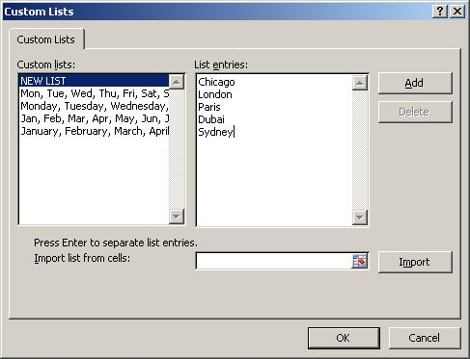

1. Click **Ok**.

**Excel 2010 +**

1. Click the **File** tab on the Ribbon and then click **Options** in the list.
2. Select the **Advanced** category in the **Excel Options** dialog box.
3. Scroll down and click the **Edit Custom Lists** button.
4. Enter the items to use in the list in the **List entries** box, or click in the **Import list from cells** box and select a range of cells on a spreadsheet that includes these items.

## Use Named Ranges

It is possible to apply your own names to cells in Excel. By applying a meaningful name it can make the cell easier to refer to, and you won’t need to use a reference such as D67 or D2:D5398.

There are other advantages to using named ranges. These include that they are absolute cell addresses, so they will not change when copying cells. And that they work across worksheets. Names ranges are unique and can be referred to from any worksheet.

To create a range name;

1. Select the cell or range of cells that you want to name.
2. Click in the **Name Box** (small box to the left of the Formula Bar).

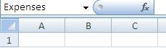

1. Type the name you want to use (no spaces and it cannot begin with a number).
2. Press **Enter**.

To quickly select a named range, click the drop down arrow on the Name Box and select the range you want to use.

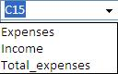

This range name can now be used whenever you need to refer to that range whether it be formulas, charts, PivotTable or Conditional Formatting ranges etc.

The formula below shows the *Expenses* named range being summed.

=SUM(Expenses)

## Convert a Cell Range from Rows to Columns

Excel always prefers data in columns like a traditional table layout. It is always assumed that your data is organised this way unless specified.

You may receive data that is arranged along rows instead. Fortunately there is an easy way to convert a cell range organised in rows to columns, and vice versa. You need to transpose the data.

1. Select the range of cells you want to convert.
2. Press **Ctrl + C** to copy the data.
3. Select the first cell of where you want to paste the range.
4. Click the **Home** tab of the Ribbon, the **Paste** drop down arrow and select **Transpose**.

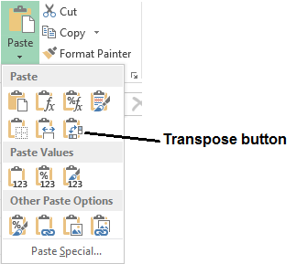

## Split a Full Name into First Name and Last Name Columns

Text such as a full name can be separated into two cells to perform better analysis such as being able to sort and filter by the last name.

Use the Text to Columns feature as an easy way of splitting text in a cell. In this example, the first name and last name are separated (delimited) by a space inside the cell.

1. Select the range of cells you want to split.
2. Click the **Data** tab on the Ribbon.
3. Click the **Text to Columns** button in the Data Tools group.
4. The Convert Text to Columns wizard appears. Select the **Delimited** option and click **Next**.
5. Select the **Space** delimiter character and click **Next**.
6. Apply any formatting you want to use (this job can be done in Excel after the data is inserted) and click **Finish**.
7. The last name is moved to the next column (you may need to insert a columns(s) ready before doing Text to Columns).

## The Camera Tool

The camera tool takes a picture of a range of cells that you can then place on a different worksheet or workbook. The picture is linked to the range of cells so that any changes to the cells are immediately updated on the picture on the other worksheet or workbook.

The camera tool can be useful when creating summary sheets and dashboards.

The camera tool is not available at first and needs to be added to the toolbar or Ribbon. To add it to the Quick Access Toolbar:

1. Click the **Customize Quick Access Toolbar** button and select **More Commands**.

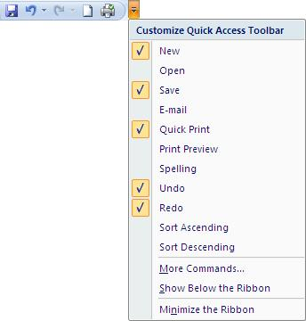

1. Click the **Choose commands from:** list arrow and select **Commands Not in the Ribbon**.
2. Scroll down the list on the left until you see the **Camera** button.
3. Select **Camera** and click the **Add** button.

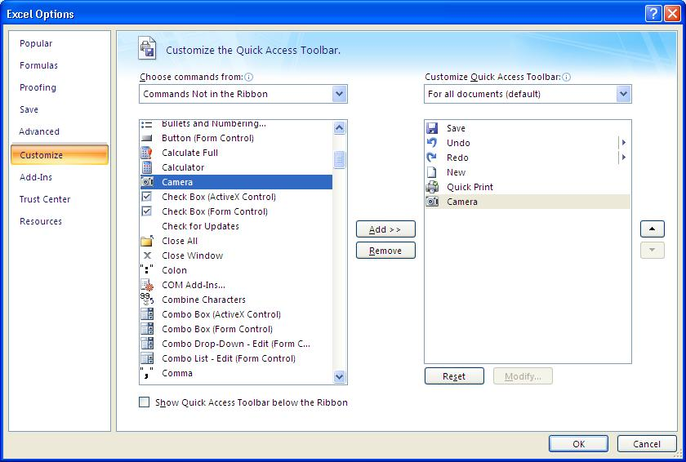

1. Click **Ok**.

With the camera button added to the Quick Access Toolbar it is now available for use.

1. Select the cells you want to take a picture of.
2. Click the **Camera** button.
3. Select the worksheet or workbook you want to place the picture.
4. Draw the picture on the sheet by clicking and dragging.

## Create a Drop Down List of Options

Validate and speed up data entry with a drop down list. It works brilliantly when the user has a selection of options to choose from such as male or female, or a list of 5 colours.

The easiest way to create a drop down list is to use the Data Validation tool.

1. Select the cells you want to apply the drop down list to.
2. Click the **Data** tab on the Ribbon and click the **Data Validation** button in the Data Tools group.
3. Click the **Allow:** list arrow and select **List**.

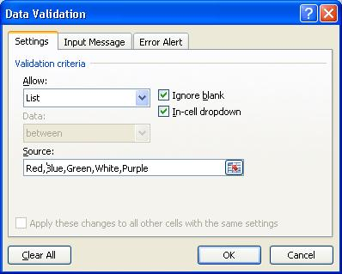

1. Click in the **Source:** box and type the items you want to use in the list separated by a comma, or select a range of cells on the spreadsheet that contains the items.
2. Click **Ok**.

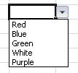

[See how to create multiple dependent drop down lists](http://www.computergaga.com/blog/creating-multiple-dependent-drop-down-lists/).

## Convert a Cell Range to a Table

A new feature that arrived with Excel 2007 is the ability to convert a cell range to a table. This has grown significantly over the versions since its inception.

This is extremely useful for creating a dynamic range from your data. Excel understands the relationship within your table and will expand it if you add new columns or rows to the range. A normal cell range is very static and does not exhibit these behaviours.

By formatting a cell range as a table it ensures that charts, PivotTables and named ranges automatically update when new columns and rows are added saving you the need to change the data source manually.

1. Select the range of cells you want to format.
2. Click the **Home** tab on the Ribbon.
3. Click the **Format as Table** button in the Styles group and select the table style you want to use.

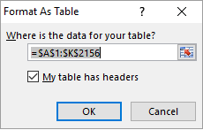

1. Check the range of cells being used for the table is correct and click **Ok**.

The table can be formatted further to change styles or remove the AutoFilter if required. This table will now automatically grow with your data.

This feature can do a lot more than is covered here and is definitely worth checking out.

## Use Sparklines for In Cell Micro-Charts

Sparklines are a feature introduced with Excel 2010 enabling you to create simple in cell micro-charts. They do not provide much detail due to their size, but they do offer a fantastic visual representation of data for at-a-glance comparisons and progress checks.

To insert a Sparkline;

1. Select the cell(s) where you want the Sparkline(s) to appear.
2. Click the **Insert** tab on the Ribbon.
3. Click the button for the type of Sparkline you want to use from the Sparkline’s group e.g. Line
4. Select the range of cells containing the data you want to chart.

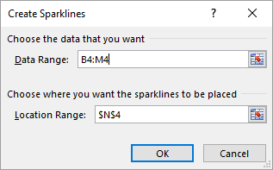

1. Click **Ok**.

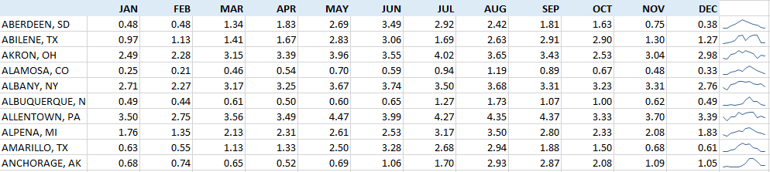

# Printing

## Print your Headers on Every Page

When you print an Excel spreadsheet on multiple pages, your headers will continue to only print on page 1. To repeat your headers on every page you need to use a feature called Print Titles.

1. Click the **Page Layout** tab on the Ribbon.
2. Click the **Print Titles** button in the Page Setup group.
3. Click in the **Rows to repeat** **at top:** box and select the row headers for the rows you want to print on every page.

The image below shows the first three rows on the spreadsheet to be repeated.

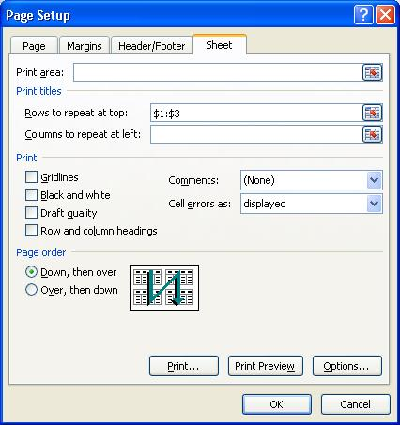

1. Click **Ok**.

## Print your Selection

By default, Excel will print the current worksheet when the print button is clicked. At times you may wish to only print a specific area of the sheet. This can be specified for future use by using a feature called the Print Area.

However you can print a selection of a sheet without the need to set up the print area. This works great for ad hoc print requirements.

**Excel 2007**

1. Select the range of cells on the sheet you want to print.
2. Click the **Office** button and select **Print**.
3. Select **Selection** from the Print what area.

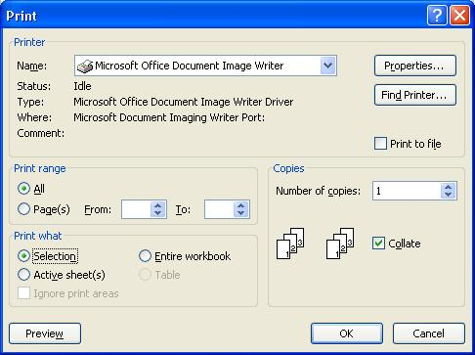

1. Click **Ok**.

**Excel 2010 +**

1. Select the range of cells on the sheet you want to print.
2. Click the **File** tab and select **Print**.
3. The print settings and print preview are displayed. Click the first drop down list under the **Settings** heading (should be set to Print Active Sheets by default) and select **Print Selection**.
4. Click the **Print** button.

## Print to One Page

When printing a large spreadsheet, trying to fit it onto as few pages as possible and making it look professional can be an exhausting task. One of the key features to aid you with this work is Excel’s scaling tool.

You can scale a print to a specific percentage such as 80% of its normal size, or fit it to a certain number of pages. Scaling only affects the print of the spreadsheet and not how it looks on screen.

The scaling options can be found on the **Page Layout** tab of the Ribbon.

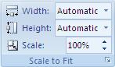

Because these options only affect the print of a spreadsheet, I tend to use the settings in the Page Setup dialog box, which is accessible by clicking the Dialog Box Launcher arrow button in the corner of the group.

Using this dialog box allows easy switching from Page Setup to Print Preview and vice versa to see how it looks.

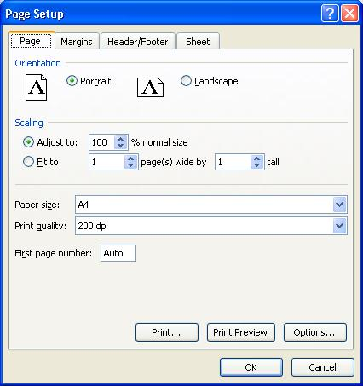

Excel 2010 + now comes with an integrated Print screen from the File tab. This is very useful as it provides Print settings, Page Setup options and the Print Preview all in one screen.

In these versions you can find the Scaling setting at the bottom of the menu in the Print Preview.

## Remove the Gridlines from a Sheet

Although gridlines are important for you to identify the location and boundaries of the cells on a sheet, it is popular to remove them for a cleaner look when a spreadsheet is completed.

1. Click the **View** tab on the Ribbon.
2. Uncheck the **Gridlines** box in the Show/Hide group.

# Using Charts

## Build a Chart

Learn to create charts in Excel to visually present your data. Remember a ‘picture tells a thousand words’. It is much easier to see comparisons, progress, trends and relationships in data when displayed using a chart.

Excel provides many charts which can be created at the click of a button.

1. Select the data you want to use for the chart (ensure your headings are also selected).
2. Click the **Insert** tab on the Ribbon.
3. Click the button for the chart you would like to use in the Charts group (From Excel 2013 there is also a **Recommended Charts** button to assist you in choosing the best chart for your data).

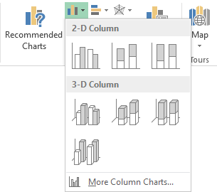

1. Select the sub-type of the chart you want from the list.
2. The chart appears on the sheet. The chart can now be formatted, resized, moved and have labels added to it.

## Change the Scale of a Chart Axis

Changing the scale of an axis on a chart can have a large effect on its display. You can make numbers appear larger or smaller than they truly are by adjusting the scale. It can also be used to remove redundant areas of a chart and provide more detail.

1. Right click on the axis you want to change and select **Format Axis**.
2. The **Format Axis** settings appear. Depending on your version of Excel, they may appear in a dialog box of task pane to the right. The image below shows the settings in Excel 2013. A popular action is to adjust the minimum as using 0 can leave a redundant space at the bottom of the chart.

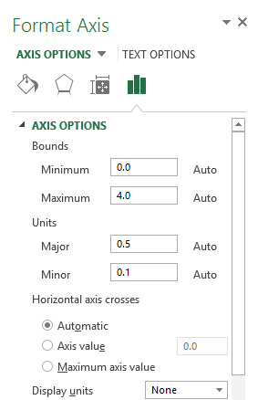

1. Type the required number in the **Minimum** or **Maximum** boxes provided.
2. 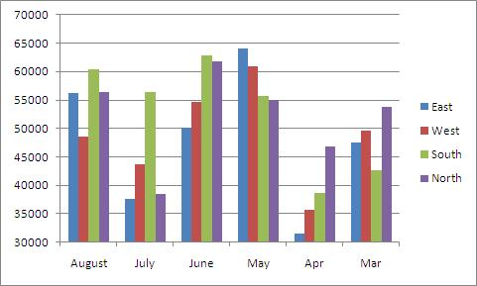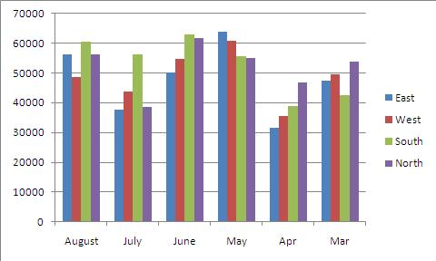Click **Ok**. The images below show a chart before and after the axis scaling.

## Apply Data Labels to a Chart

Data Labels can be added to a chart to add more detail such as to show the values, percentages or labels of the data series.

Data Labels are often added to supplement or even replace the value axis and gridlines. The image below shows data labels being used instead of the gridlines and value axis for a neater approach.

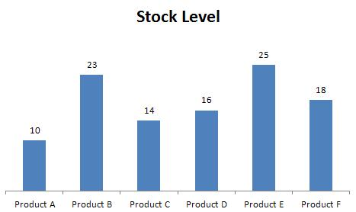

To add data labels to a chart;

**In Excel 2007 and Excel 2010**

1. Click the **Layout** tab under Chart Tools on the Ribbon.
2. Click the **Data Labels** button in the Labels group.
3. Select the position on the chart you want to labels to appear

**In Excel 2013 +**

1. Click the **Design** tab under Chart Tools on the Ribbon.
2. Click the **Add Chart Element** button.
3. Select Data Labels and then the position on the chart you wat them to appear.

The data labels display the values of the data series by default. To change the type of data being displayed, or to modify some other data labels settings, select **More Data Label Options** from the list.

## Add a Secondary Axis

Add a secondary axis to a chart when you need different data types, or values that are very different to each other, to co-exist on the same chart.

In the example below the chart shows exam grades by percentage in the first axis and attendance figures by number in the second axis. A secondary axis is required as you could not present values going from 0.1 to 1.0, and values from 150 to 200 on one axis.

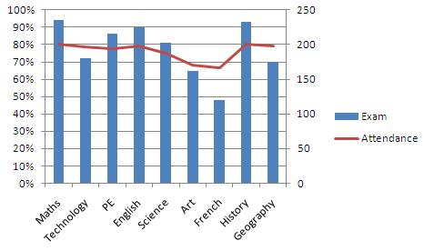

1. Right click on the data series you want to scale on the secondary axis and select **Format Data Series**.
2. The **Format Data Series** settings appear. The image below shows how they appear in Excel 2013. Select the **Secondary Axis** option in the Series Options category.

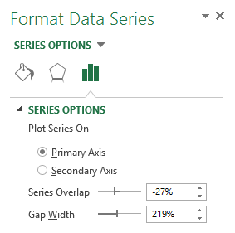

## Save the Chart as a Template

After you have made all of your formatting changes and added the required labels to the chart, you may want to save it as a chart template. This will save the chart settings making it very easy to use again in the future, and saving you the effort of repeating all of your formatting changes.

This works fantastic for charts you create on a regular basis that require consistent layout and formatting.

**In Excel 2007 and Excel 2010**

1. Select the chart you want to save as a template.
2. Click the **Design** tab under Chart Tools on the Ribbon.
3. Click the **Save As Template** button in the Type group.

**In Excel 2013 +**

Right mouse click on the chart and select **Save as Template**.

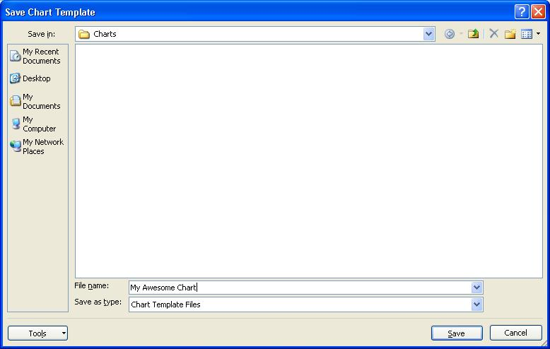

1. Enter a **File name** for the chart and click **Save**.

The chart template is created. To use the chart template in the future;

1. Click the Dialog Box Launcher button in the corner of the Charts group.
2. Select **Templates** on the left.
3. The chart template you created should be visible. Select it and click **Ok**.