

**About Me**

Hello everyone,

My name is Alan Murray. I live in Ipswich in the United Kingdom with my wife and 2 children.

I work as an IT Trainer and have done for the last 20 years.

Working as an IT Trainer, I visit many organisations to train their staff in the use of Excel.

This means I get to meet many

wonderful people and also get a good understanding of what Excel skills users’ need, and want to know.

I set up Computergaga to help spread these in-demand tips and skills to others.

I’m an Excel enthusiast and am always learning myself so encourage comments and community spirit on my blog. I hope to see you there.

**Want to be an Excel Superhero?**



**Learn all the skills you need to know to be an Excel Expert**

|  |  |
| --- | --- |
| * **IF Functions** * **PivotTables** * **VLOOKUP** * **Charts** | * **Conditional Formatting** * **Manipulating Text** * **Macros** * **And much, much more** |

[**Click Here to Sign Up Now**](http://goo.gl/q1gOjs)

# 1. Adding Numbers with Leading Zeros

When entering numbers into a cell in Excel, you may wish to keep the leading zeros. Examples might include when entering phone numbers, or employee

ID’s.

However Excel will not allow this and will remove any leading zeros. For example, if you typed 002 into Excel, it would display 2. The zeros are deemed redundant.

There are two methods we can use to make Excel keep the leading zeros. One way is to enter them as text, and the other is to format them with zeros (this approach will keep the value numeric).

To enter a number as text (such as a phone number), we can simply precede the number with a single quotation ‘. This tells Excel that you have typed a number, but want it stored as text. Excel will react like in the image below.

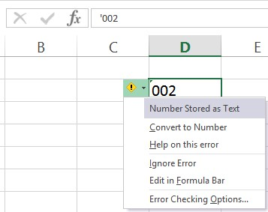

You can see in the Formula Bar that a single quotation was typed. In the cell a warning icon is displayed, and when I click on it I am provided with a quick way to convert it to a number if this was a mistake.

To remove the warning and keep it as text with the leading zero, click **Ignore Error**.

Another way to enter a number with leading zeros is to customise the formatting of the number. Let’s imagine that we are entering employee ID’s which are exactly 8 characters in length.

1. Select the range of cells you want to apply the formatting to.
2. Right mouse click on the selected cells and click **Format Cells**, or press **Ctrl + 1** (neat Excel shortcut there ).
3. Select the **Number** tab, **Custom** from the list on the left and enter 00000000 (eight zeros) into the **Type** box.

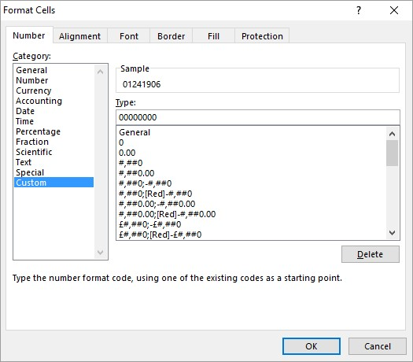

In the sample area of the image above you can see Excel placing a 0 at the start of the employee ID, which would otherwise only be 7 numbers in length.

The 0’s enter into the **Type** box force Excel to display a number. Therefore if we do not enter one, Excel puts in a 0.

# 2. Restrict Values with Data Validation

When manipulating, analysing and reporting on data, these tasks will only be as successful as the data itself. There is no point being a PivotTable guru if your colleagues are mistyping names, and not entering dates correctly.

The Data Validation tool in Excel is great for ensuring the data being entered is clean and correct. You can write all kinds of validation rules to check data, however the most common use of Data Validation is to create a drop down list of options.

Let’s look at how to do this;

1. Select the range of cells you want to apply the Data Validation rules to.
2. Click the **Data** tab and then **Data Validation**.
3. On the **Settings** tab, select List from the **Allow** options.
4. You can now enter the list entries into the **Source** box separating each one with a comma (shown in image below).

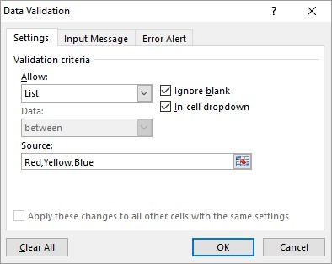

Or

Select a range of cells that contains the entries for the list.

And we now have a list in each of the cells that you selected [(Check out how to create multiple dependent drop down lists)](http://www.computergaga.com/blog/creating-multiple-dependent-drop-down-lists/).

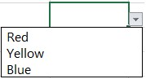

You can type in the cells, but if you try and enter anything that is not in the list, Excel will refuse it.

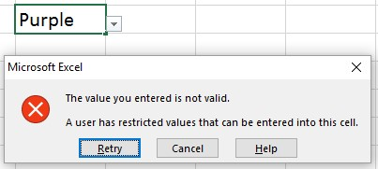

# 3. Navigate Large Lists Using the Keyboard

When working with large lists even the simple art of navigation can be awkward and cumbersome, unless you know some trusty shortcuts.

* Pressing **Ctrl + Arrow key** will jump you to the end of that row or column (it stops at the first empty cell, so depends how your list is structured).
* **Ctrl + Home** or **End** will jump you to the first cell of the table (Home), or the last cell of the table (End).
* By also pressing the **Shift** key during these shortcuts, it will select the cells.
* Pressing **Ctrl + Shift + 8** selects the current region. This means it selects all the cells from the current range you are in.

# 4. Quickly Enter Todays Date

Do you have to enter todays date often?

Then you will love this keyboard shortcut that enters it for you.

It is **Ctrl + ;** Enjoy!

That will save time and also ensure there are no mistakes entering it.

# 5. Insert Multiple Rows or Columns at Once

Excel will insert the same number of rows and columns that you have selected. So if you want to insert four new rows after row 8; Select rows 9 to 12.

Right mouse click on the selected rows and click **Insert**.

The same technique works for columns.

# 6. Select All the Formulas on a Sheet

Excel has a wonderful feature called **Go To Special** which enables you to select cells on a spreadsheet that meet certain conditions.

Possibly it’s most common use is to select ALL the formulas on the sheet.

You may be doing this so that you can protect the cells with formulas, or change the background colour of them.

Click the **Home** tab, then **Find & Select** and then **Formulas**.

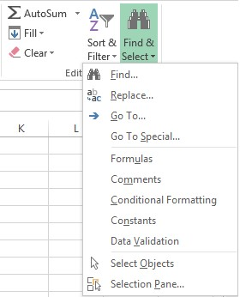

Click the **Go To Special** option from **Find & Select** to see all of the options that this amazing tool has. Other GREAT options include selecting all the blank cells in a range, those with Data Validation rules or those containing formula error.

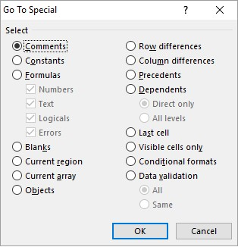

# 7. Copy Formulas to the Bottom of a List WITHOUT Dragging

When working with large lists, dragging the Fill handle to copy formulas can be awkward and frustrating.

Great News.

Double click the Fill handle and Excel will copy it to the bottom of the list for you. AMAZING!



Excel will use the column to the left as a guide. When that column ends (at a blank cell), your copying will stop.

# 8. Switch a List from Rows to Columns

In an ideal world for Excel, your data should be in a classic table format. By this I mean that your headers will be in the top row and each row will be a record, with the columns as type of information about that record.

However especially when importing data from databases and online services it does not always appear that way.

Fortunately Excel provides a simple way to switch your data from rows to columns and it’s called Transpose.

1. Select the range of cells you want to rotate.
2. Click **Home** and then **Copy** or press **Ctrl + C**.
3. Click in a destination cell (you can always move it afterwards).
4. Click the **Home** tab, the list arrow of the **Paste** button and select the **Transpose** option.

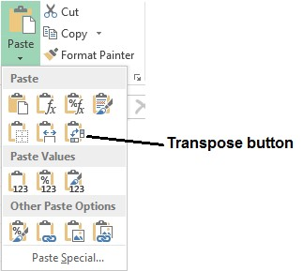

# 9. The AMAZING Button to Copy Formatting Between Cells Quickly

One of my favourite buttons in Excel is the Format Painter. This button can be used to copy formatting from one cell to another quickly.

It can save tons of time and also ensure consistent formatting across a spreadsheet.

Simply select the cell that contains the formatting you want to copy.

Click the **Format Painter** button on the **Home** tab.



Select the cell or range of cells that you want to apply the formatting to.

It is simple, but very, very awesome.

# 10.Removing the Formula from a Cell by Pasting Values Only

When copying and pasting cells, Excel pastes everything about the cell including its formula, formatting and validation rules.

Fortunately, there is a feature called Paste Special which enables us to choose which elements of the copied data that we want to paste.

Two of the most common Paste Special options are paste **Values** and paste **Values** **and** **Number Formatting**.

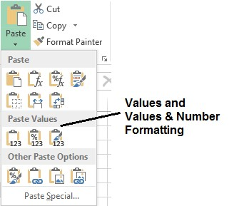

These options are great when you do not want a formula to calculate anymore. You can copy and paste Values to effectively keep the result, but remove the underlying formula.

These pasting options also come in handy when sending spreadsheets to clients and other external recipients for whom you do not wish to view your formulas.

# 11.Instant Formulas on the Status Bar

Using tools such as formulas and PivotTables ([Learn how to use PivotTables in Excel)](http://www.computergaga.com/tips/learn_pivot_tables-excel_pivot_tables_tutorial.html) are great. They are powerful analytical tools that Excel users are very passionate about.

However sometimes you don’t need that stuff. Whenever you select a range of numbers, Excel automatically calculates the sum, count and average down on the Status Bar.

Although they cannot compete with complex formulas or PivotTables, these quick formulas will solve most basic needs. And when combined with filtering can become a very powerful analytical tool themselves.

The image below shows a list that has been filtered, and then column J is selected to produce the calculations down on the Status Bar.

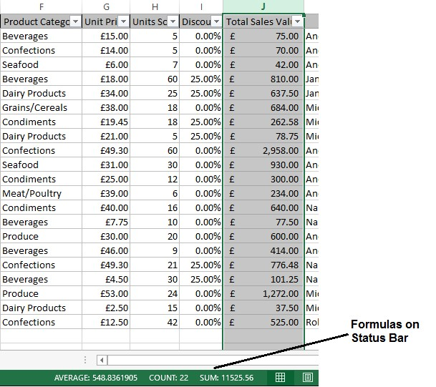

# 12.Define Names for Easier Referencing

You can define names to cell ranges in Excel for easier referencing. So instead of writing a formula as *=SUM(D2:D20)*, it could say *=SUM(Expenses)*.

It is a similar concept to the way in which we name buildings. What we call The White House is 1600 Pennsylvania Avenue NW, but we simply know it as The White House.

These names are more meaningful than cell addresses, and they are also unique for the entire workbook. This makes them especially useful when writing formulas referencing cells on different worksheets.

To define a name;

Select the range of cells you want to name. Click in the Name Box and type the name you want to use, then press **Enter**.

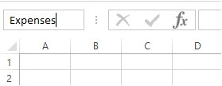

When naming cells you cannot use spaces, start the name with a number or use special characters such as % or/.

This name can then be used when referencing those cells.

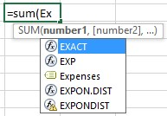

# 13.Split Text across Columns

If you have data such as people’s names, addresses and URL’s in one column, you may want to split the data across multiple columns. For example, to separate people’s first name and last name. To do this;

1. Insert additional columns next to the column you are going to split. So for splitting first name and last name you will need one extra column for the last name.

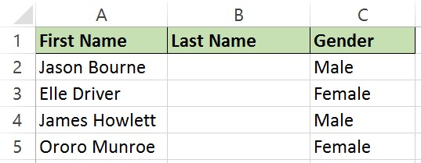

1. Select the range of cells in the column that you want to split. Click the **Data** tab on the Ribbon and then **Text to Columns**.
2. A wizard appears with step 1 asking how to split the columns. In this example we select **Delimited**. Click **Next**.
3. In step 2 you need to select how the columns data is delimited. In this example, it is a space. Click **Next**.

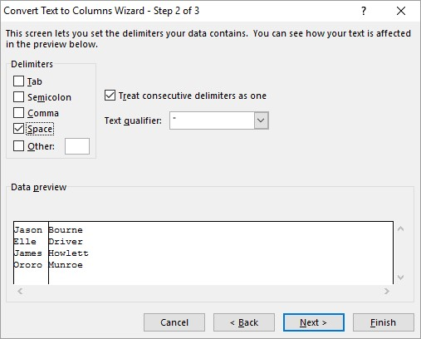

1. In the 3rd and final step you can change the format of the columns. In this example it is not necessary as each column is a General format. Click **Finish**.

The Text to Columns feature is useful for the most common situations at splitting data from a column. Check out this tutorial for [3 more advanced techniques at separating text in a column.](http://www.computergaga.com/blog/separate-text-different-cells/)

# 14.The AWESOME Flash Fill for Data Manipulation

Flash Fill is an AMAZING tool that was released with Excel 2013. It can be used to perform typical data manipulation tasks such as extracting text, concatenating, reversing text and formatting numbers and dates.

It does this by recognising a pattern when you are filling cells. It is a huge timesaving tool.

Let’s look at two examples of its use.

In this example, I want to reverse the names in the first column. I can do this by typing an example of what I want (shown in the image below), selecting the cell and clicking the **Data** tab and **Flash Fill** (or press **Ctrl + E**).

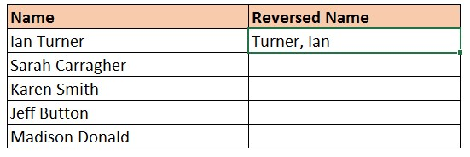

And Flash Fill will repeat the pattern.

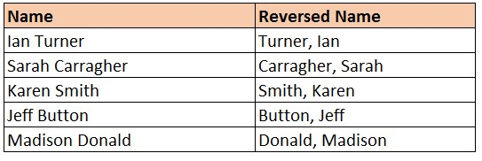

In this example, I want to extract the names from the email addresses in the first column.

Another way of using Flash Fill is to type the first example of what you want it to do, then copy that down to the other cells in the list in the usual way with the AutoFill handle.

After copying down, AutoFill will do its thing as shown below. Click the **AutoFill Options** tag and select **Flash Fill**.

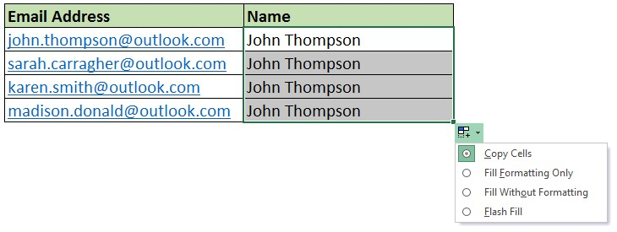

# 15.Format Dates to Show the Day of the Week

Excel provides multiple date formats but not one that shows the day of week. The day of the week can be a useful thing to display. By creating a custom format we can display this however we wish.

1. Highlight the range of cells you want to format, and then right mouse click and select **Format Cells**.
2. Select the **Number** tab and then **Custom** from the list.
3. In the **Type** field, enter dddd before the date followed by a space. In the sample above you can see the day displayed along with the date.

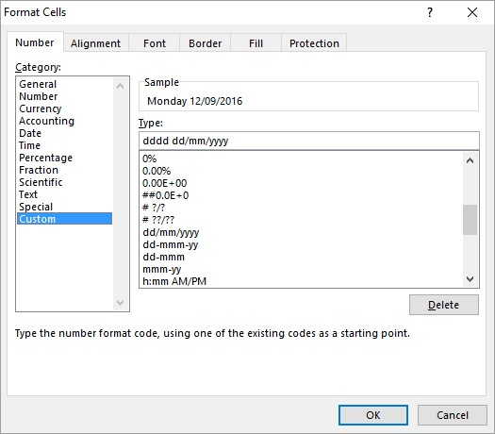

You can play around with the number of d’s, m’s and y’s to change how the date is formatted.

# 16.Use Comments for Descriptive Text

Excel is not very good at handling large amounts of text in its cells. It is not its primary purpose. Don’t misunderstand me, Excel can certainly handle large amounts of text and we can manipulate and analyse it in many ways.

However it can look unwieldy and make your spreadsheets cumbersome.

So, unless you need that text in a cell for analytical purposes, Comments offer a great alternative [(You can even insert pictures into your comments)](http://www.computergaga.com/blog/insert-a-picture-into-a-comment/).

To insert a comment;

Right mouse click on the cell you want to insert the comment to and click **Insert Comment**.

Type the text in and click on the worksheet outside the comment.

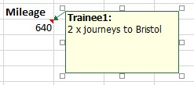

Excel displays a red triangle in the top right corner of the cell so that people know there is a comment there.

The comment will appear when you position your mouse pointer over the cell, and then disappear again when you move your mouse pointer away.

# 17.Quickly Remove the Duplicates from a List

Duplicate values are a very common problem in Excel that needs dealing with. Very helpful then that in Excel 2007 a Remove Duplicates feature was born.

Simply select the range of cells that you want to remove the duplicates from. Click the **Data** tab and then the **Remove Duplicates** button.

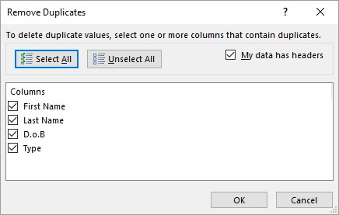

Excel displays the headers from the range of cells selected. By default, all headers are checked. This means Excel will only recognise a record as a duplicate if every column is the same.

This is your opportunity to remove any check boxes that are not required, and click **Ok**.

Job done. Excel removes all duplicates and tells you the result.

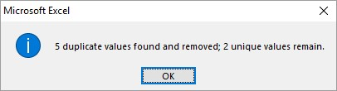

# 18.Enter a Schedule of Dates in Seconds

A common use of Excel will be to monitor some kind of schedule such as a series of payments, project tasks, maintenance schedule or shift rota.

Very useful then that you can create such as schedule quicker than it took me to type this quick tip.

Enter the first two dates of the schedule. This is done to indicate to Excel the pattern to follow.

In the image below I am using a schedule of every 4 days. So I start by entering the first two dates of the 06/09/2016 and 10/09/2016.

You can then click and drag the Fill handle down and Excel picks up every 4th date for you automatically.

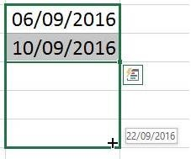

Check out the different options and what this Fill handle can do with dates. As long as the schedule follows a recurring pattern, Excel could save you a lot of time.

# 19.Hide and Unhide Columns

Hiding columns is very useful to temporarily remove data from sight, so that you can focus on just what you need to see right now. This is really useful when printing as hidden columns are not printed.

To hide a column, right mouse click on the column header and click **Hide**.

The column is hidden. It is easy to know when a column is hidden as you notice the letter is missing from the column headers (like in the image below).

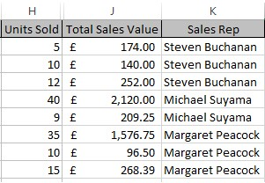

To unhide a column, select the range of columns either side of the missing one(s). So in the example above you would select H to J. Then right mouse click and select **Unhide**.

# 20.Clear Cells of Everything

When you select a range of cells in Excel and press the **Delete** key on the keyboard, it only removes the cells content.

This can surprise a lot of people and cause problems with their resulting formulas or charts.

Pressing the **Delete** key does not remove formatting, validation rules, hyperlinks or comments.

Now this is a good thing that Excel does this, but it can cause confusion.

To effectively clear everything from a cell, click the **Home** tab, the **Clear** button and select **Clear All**.

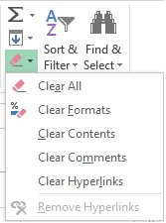

Note that there are also useful options to clear only the cells formatting, or only the hyperlinks.

# 21.Join Text from Multiple Cells into One

You may have data such as a name or some kind of code split over multiple columns, and you would like to join them together in a single column.

You can do this using a formula and the ampersand (&) character.

For example, in the image below the formula in cell C2 has created a full name from the first name in A2, a space, and then the last name in B2.

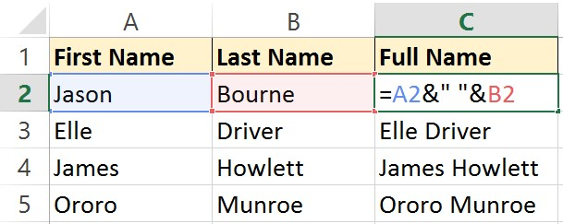

# 22.Filter by Date

You don’t always need complicated formulas and PivotTables to get the answers you need from your data, especially when getting results from a specific date range.

Make the most of the **brilliant** date filter options in Excel.

There are all kinds of real-time date options such as This Month, Last Week or Yesterday.

You also have the ability to specify the year, month or days that you want to filter by. The + signs next to the years in the image below will expand the year so that you can specify months.

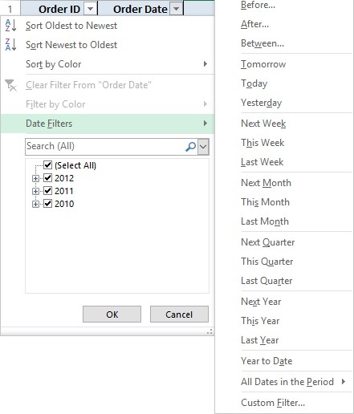

# 23.Print the Headers on Every Page

When printing on more than one page, you will want your table headers repeated on every page. Otherwise it will be confusing and difficult for people to read from pages 2 onwards.

To do this we can use the Print Titles feature of Excel.

Click the **Page Layout** tab and then **Print Titles**.

Click in the **Rows to repeat at top** box and select the row(s) on the worksheet you want repeated on every printed page.

The **Columns to repeat at left** box can be used if your table columns don’t fit on one page.

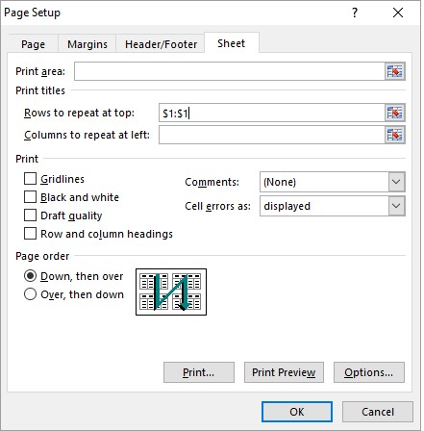

# 24.Print the Selected Range ONLY

By default, Excel prints the entire worksheet. However sometimes you only want a specific chart or range of cells on that worksheet to print.

To do this, begin by selecting the chart or range of cells. Then click **File** > **Print**.

If you have selected a chart, then Excel will automatically print only the chart. It will also be neatly centred on the page.

However if you have selected a range of cells, you will need to select **Print Selection** from the list under **Settings** (as shown in the image below).

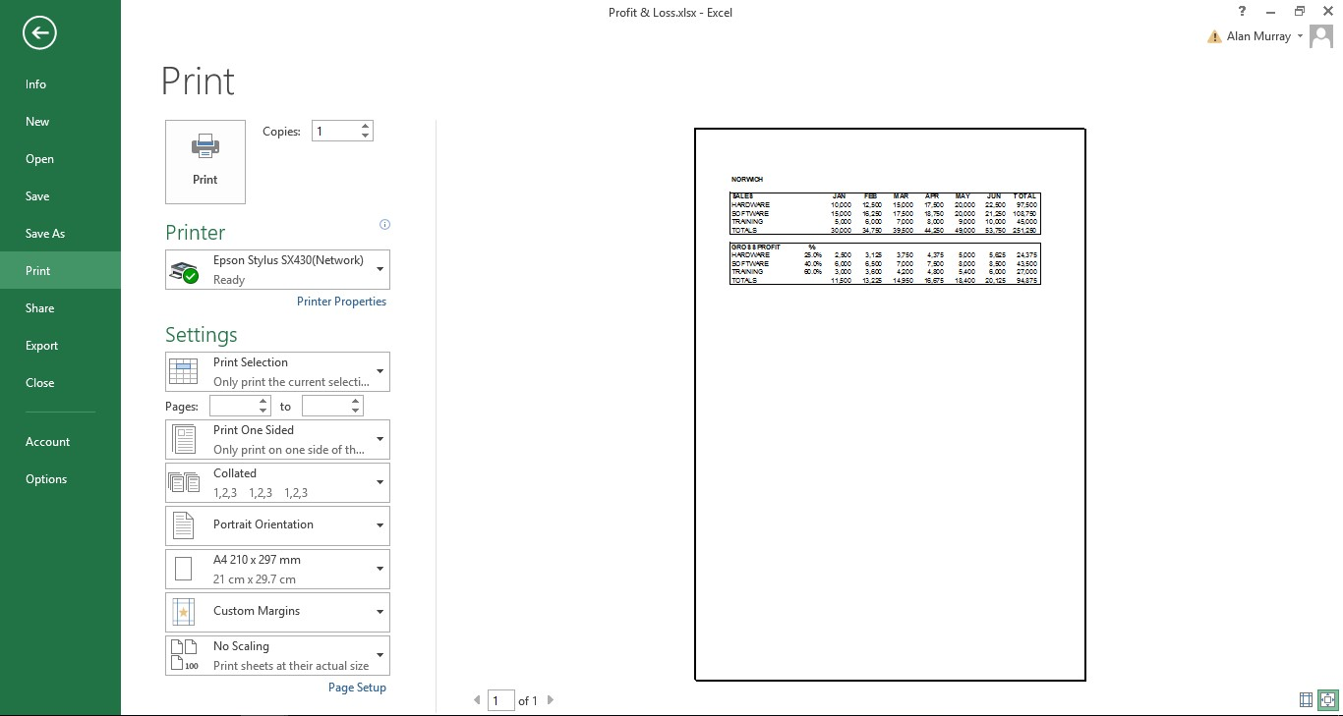

# 25.Save Time on Regular Queries by Saving Custom Views

Custom Views are a tool in Excel that many people are not familiar with. They can be very useful though if you perform regular filtering and/or printing tasks.

This is because a Custom View saves your filter settings, any hidden columns and also your printing settings. So if you perform a mixture of regular filtering or printing tasks then this tool is a diamond. To add a Custom View;

1. Apply any filters, hide any columns and setup your printing settings how you want.
2. Then click the **View** tab, and **Custom Views**.
3. Click the **Add** button.
4. Enter a name for the Custom View and select whether you want to save both the **Print settings** and/or **Hidden rows, columns and filter settings**.

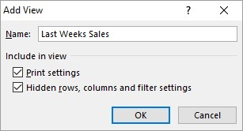

1. Click **Ok**.

To show a Custom View;

1. Click **View** and then the **Custom Views** button.
2. Select the view you want to apply and click **Show**.

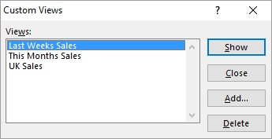

# 26.Display Negative Values in Red

To distinguish negative values easier on a worksheet you can display them in red. To do this we will apply a custom format.

1. Select the range of cells to format.
2. Right mouse click the selected range and click **Format Cells**.
3. Select the **Number** tab and then **Custom** from the list on the left.
4. Scroll down through the custom format options to find the one you want. There are few different number formats that will apply red to negative values.

In the image below I have selected one that displays the value as currency also. To the left of the semi colon is the format of the positive number, and to the right the format of the negative value.

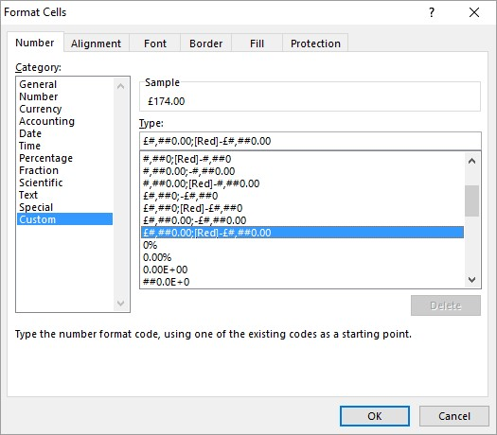

# 27. Freeze Parts of a Spreadsheet to Stay Visible on Screen

Spreadsheets are normally quite large right? So being able to freeze parts of the sheet so that they stay visible when you scroll is an important Excel hack to know.

In a typical table example, you will want to freeze your headers so they remain on screen.

These headers are probably in the first row, so to freeze them you can click the **View** tab, **Freeze Panes** and then **Freeze Top Row**.

However, maybe your headers are in the top 3 rows of the sheet. What now?

Well, we need to tell Excel where they are. We do this by clicking in the cell directly after the parts of the sheet we want to freeze.

So for the top 3 rows, that would be cell A4.

We then click the **View** tab, **Freeze Panes** and then **Freeze Panes**.

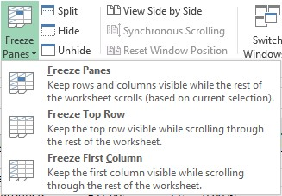

And if I wanted to freeze the top 3 rows AND column A?

Yes, you would click in cell B4.

Now the top 3 rows are frozen for vertical scrolling, and the first column frozen for horizontal scrolling.

**[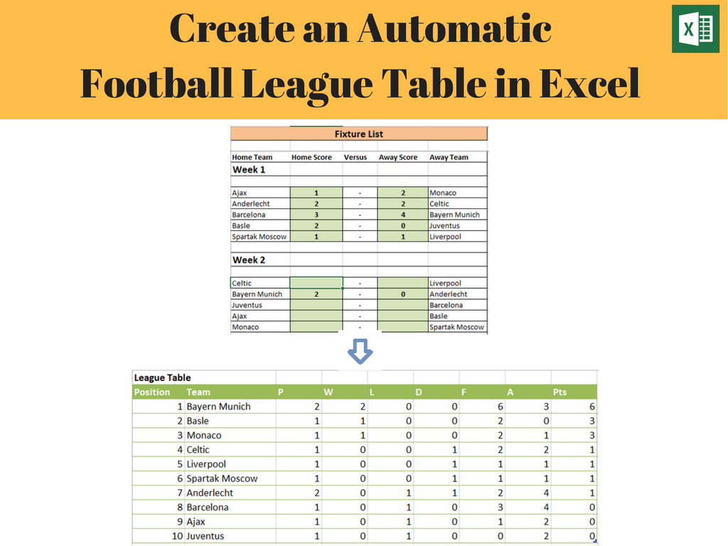](http://skl.sh/2bvcJb5)**

* Learn all the skills required to create your own automatic football league table spreadsheet
* The league table calculates the rankings and league data as results are entered into the fixture list
* This example can be adapted for other sports league examples

[**Click Here to Enrol Now**](http://skl.sh/2bvcJb5)